Hands-On Electrical Engineering Laboratories for Middle and High School Students
2017 Report

The Department of Electrical and Computer Engineering at Stony Brook University (SBU) has run the Hands-On Electrical Engineering Laboratories for Middle and High School Students program during the academic year 2016-2017. This effort is strongly committed to serve students in high needs schools and to meet the requirements of the Next Generation Science Standards (NGSS).

The program offered two components, one in the form of after school activities and another one in the form of engineering teaching laboratories (all aligned to the NGSS):
- After school engineering activities at a high needs local high school (Central Islip) ran during the Fall and Spring semesters and at each of them, 20 students participated in 6 hands-on electrical/computer engineering activities of two and a half hours each.
- Engineering Teaching Laboratories – Six-hour-long hands-on engineering activities were prepared and implemented as on campus offerings. Ten different groups (two middle schools and eight high schools) from local schools attended the pilot sessions during the Spring semester. The piloted activities were geared towards high school level. For next academic year, we are planning to expand the reach of the program to more schools and include new activities.

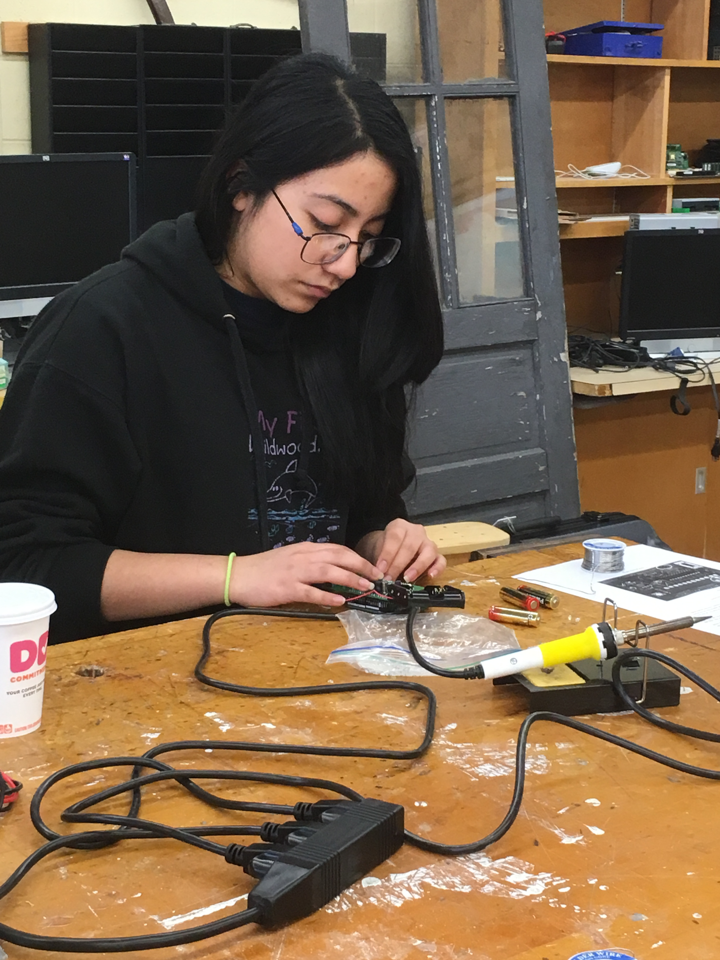
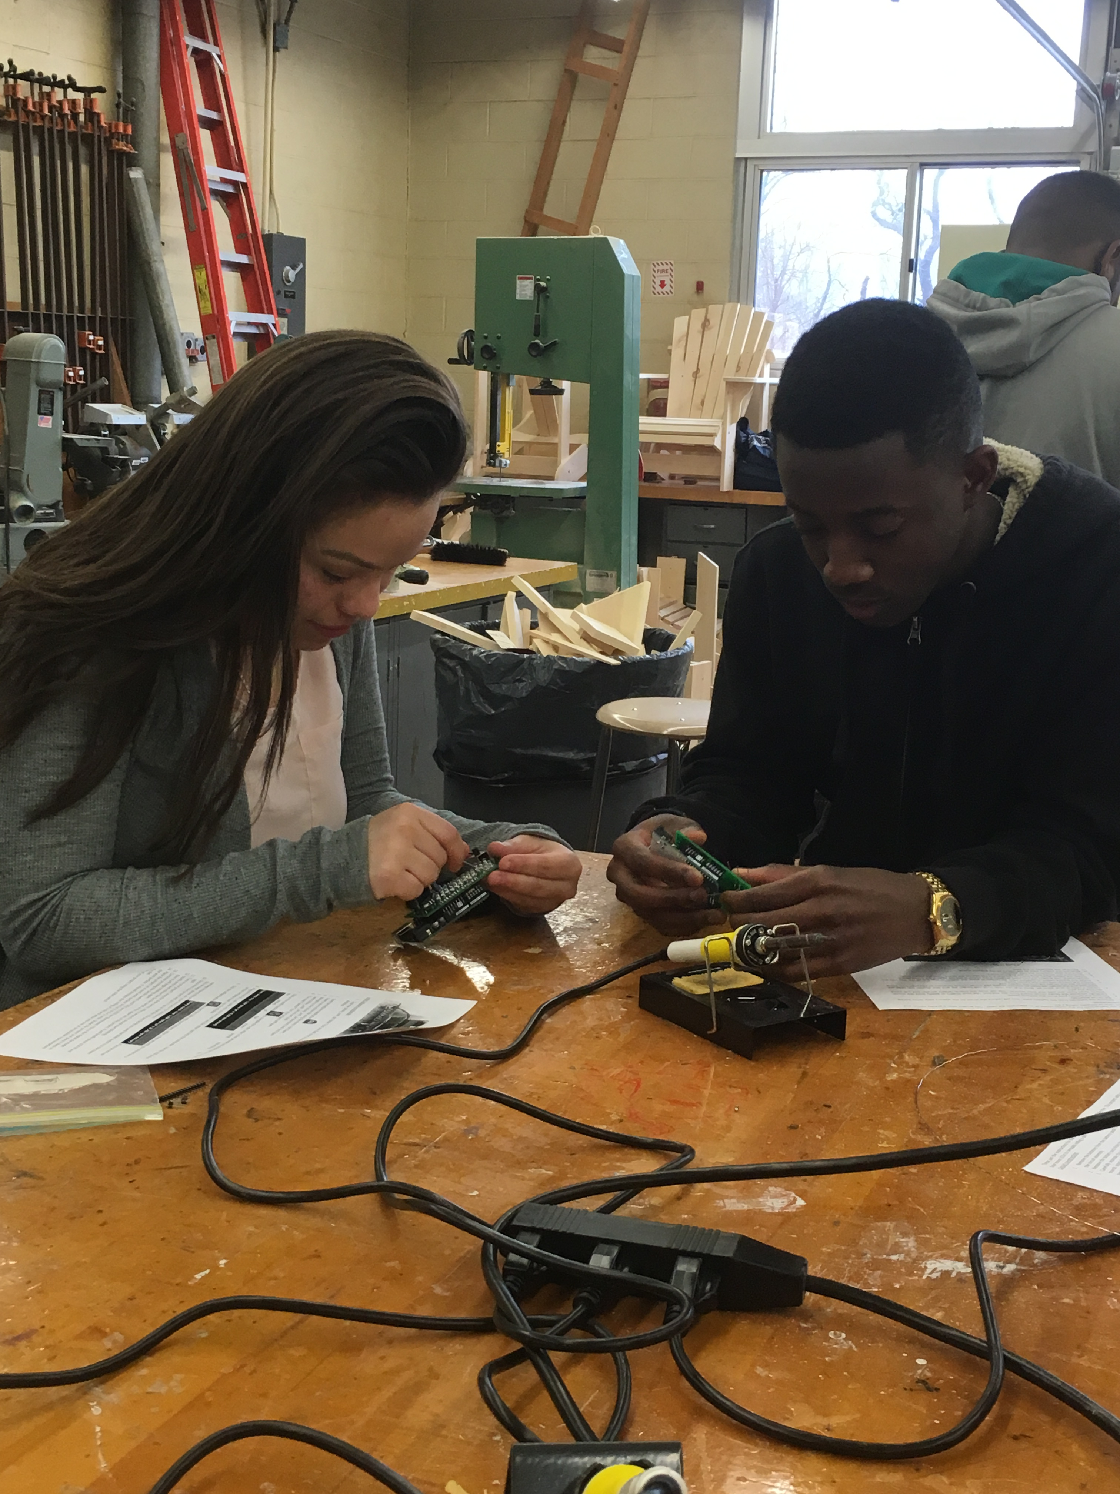
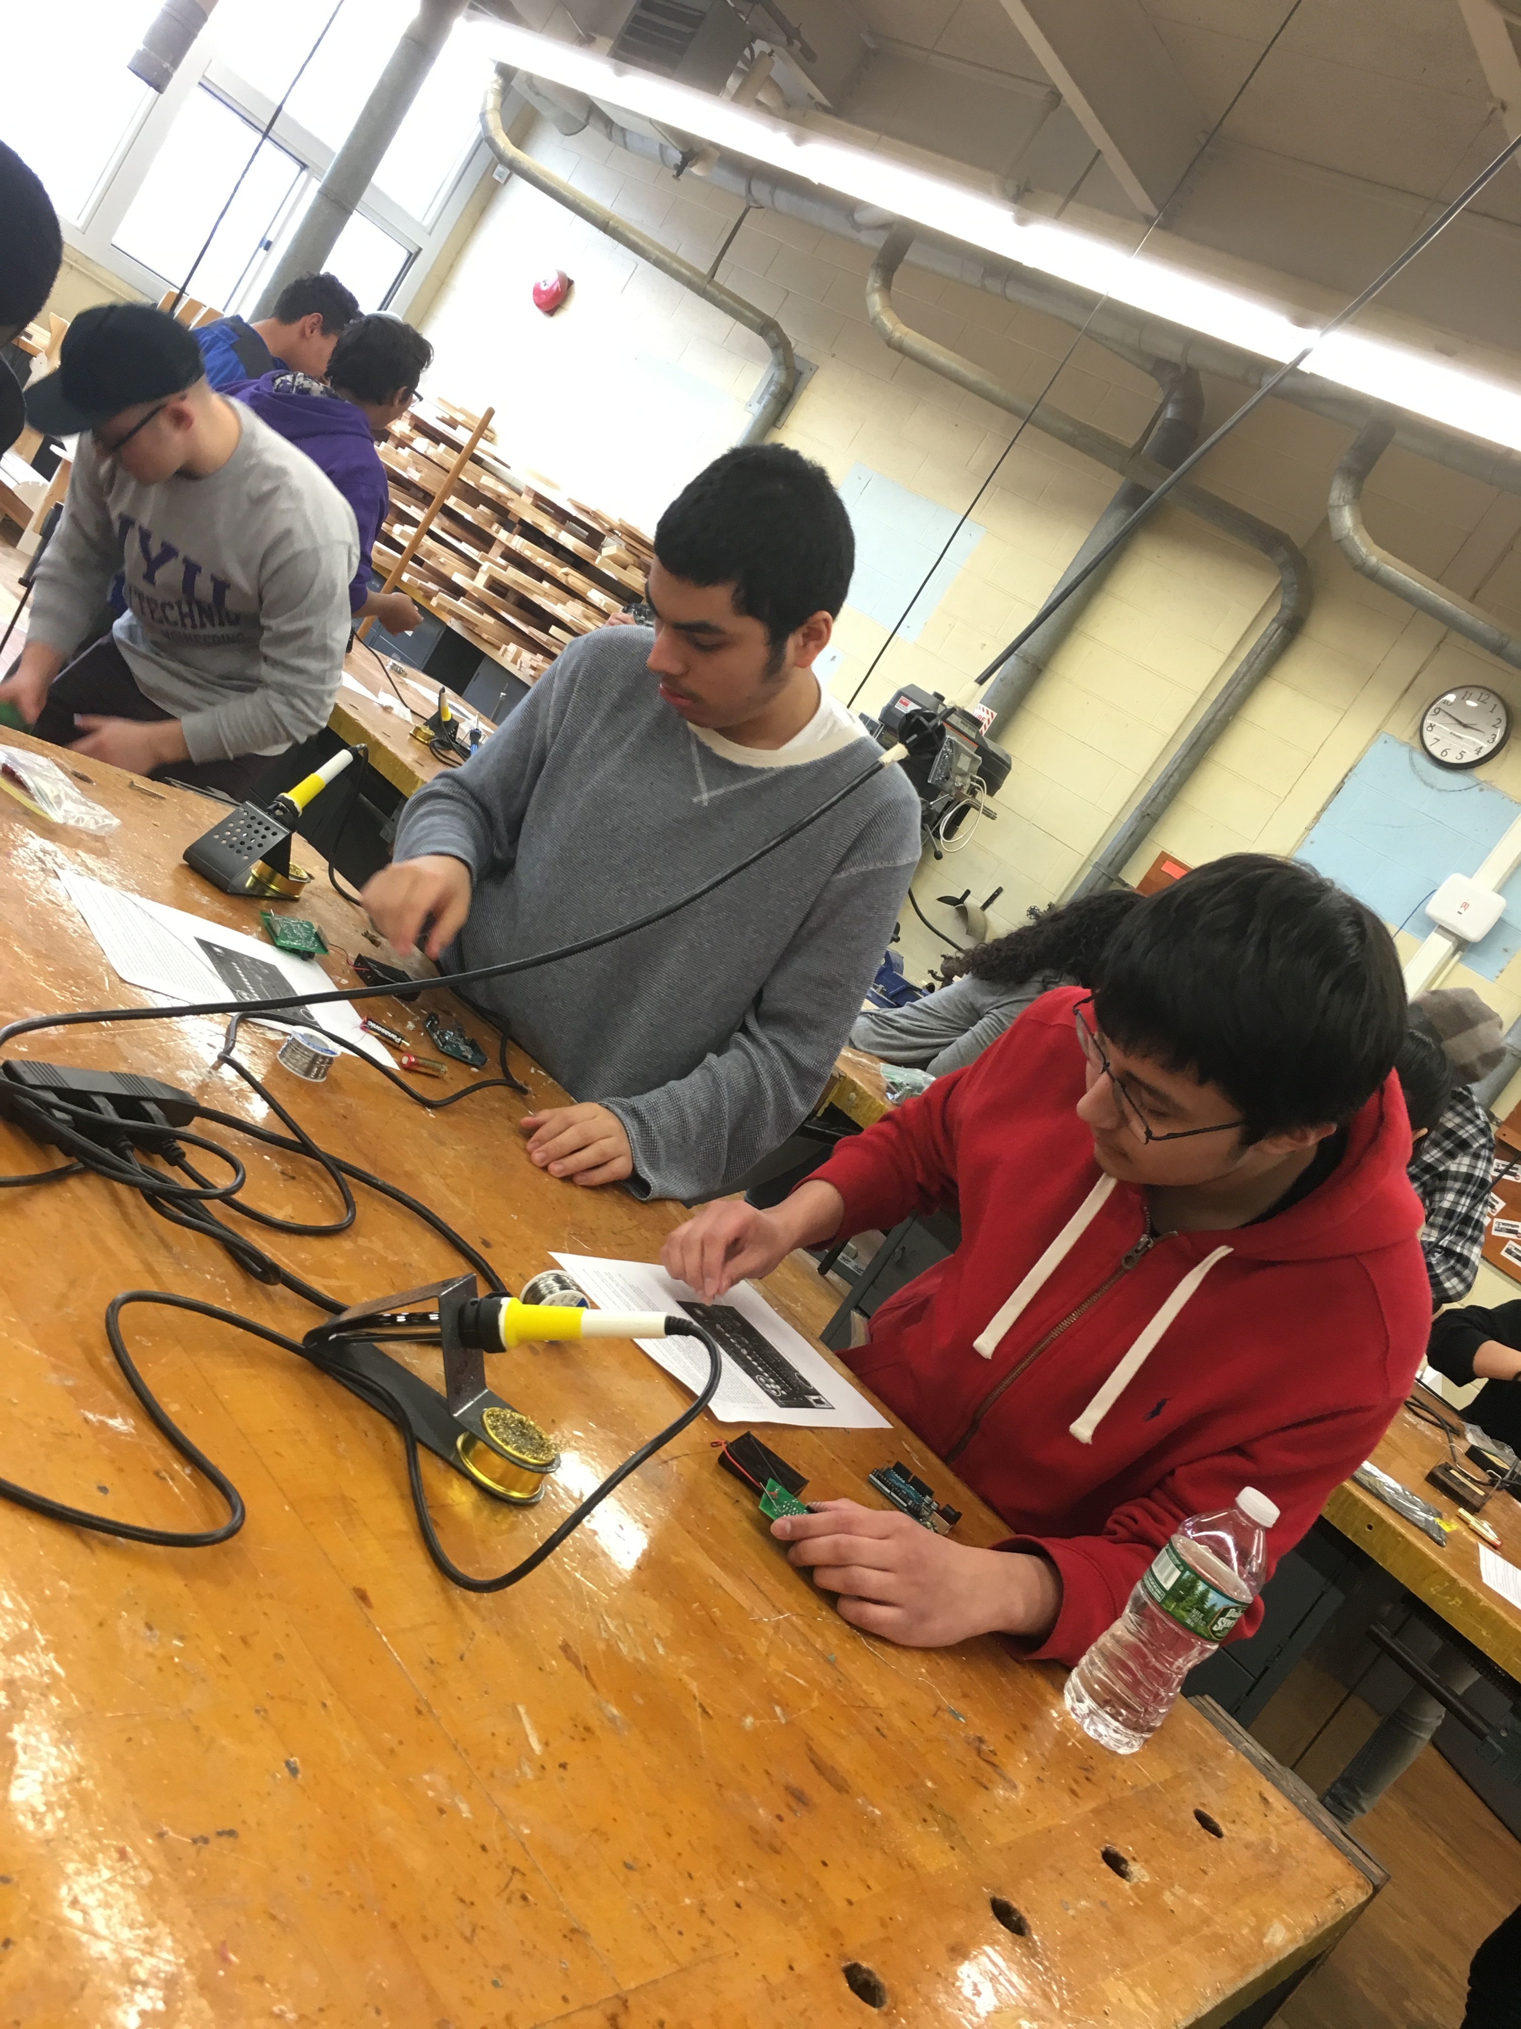

The funding by IEEE-CAS has supported the instruction and the preparation of materials for the activities preparation as well as fellowships for underrepresented undergraduate and graduate students instructing and assisting in the activities.

Data from surveys given to students demonstrated that a high percentage of the students who attended the program showed an increase in engineering knowledge and application of technical concepts. The majority also expressed increased interest in attending college, increased interest in majoring in engineering, an appreciation of soldering as a useful skill, and recognition of how physics concepts were applied to engineering design. Students (N = 69) responded positively to the following representative surveys statements:
- I enjoyed this engineering lab activity. [84% strongly agree, 16% agree]
- This visit increased my interest in pursuing an engineering-related field as an area of study in college. [38% strongly agree, 26% agree]
- This visit increased my interest in attending college. [58% strongly agree, 19% agree]
- This laboratory increased my understanding of the process of electrical engineering design. [48% strongly agree, 48% agree]
- I understand how the home security device relates to concepts I learned in physics class. [52% strongly agree, 36% agree]
Students were asked to comment on what they liked about the engineering laboratory activities. Notable students responses included: “I was able to experience hands on tasks suited for my career field,” “I liked the hands on work because we really get to experience making a circuit ourselves. I have never used a real circuit board to make a basic device before,” “It was very interactive and understandable,” “I enjoyed how we were able to build a device that could be applicable in the real world. I also appreciate how helpful the instructors were.” Additional innovative laboratory activities will be developed this summer and implemented this fall to build upon the success of the pilot.

