**Report from international director Western-European AESS chapters on chapter chairs activities**

14 September 2015

Leo P. Ligthart

Director Western-Europe of IEEE-AESS

During the spring meeting 2015 of the BoG IEEE-AESS it was concluded that AESS chapters in Europe are not so visible as wanted within AESS. Especially the smaller and medium small countries seldom show their activities. Therefore it was decided that the international director Western-European of IEEE-AESS should approach the chair holders and ask for their activities in last and coming year.

Because the AESS chapter activities in the big countries as Germany, Italy, France, Spain and UK are better known in the BoG, I decided not to approach these chapters.

Chapter chairs activities in Europe have not yet been overviewed. Based on the information I got from Judy Scharmann and Erik Blasch I came to the conclusion that first the AESS chapter chairs in medium/small countries should be approached.

I send out an email to 14 European AESS chapter (or section) chair holders:

Switzerland, Sweden, Slovenia, Servia, Macedonia, Finland, Estonia, Denmark, Ukraine, Romania, Bulgaria, Ceskolovenska, Poland and Benelux.

Unfortunately, not all chapter chairs responded even after I sent a reminder. 3 Countries did not respond: Romania, Bulgaria and Poland. I am not sure if the correct persons were addressed. We have to find out.

From 4 countries I received the message that there is no AESS section and there are no AESS activities. Those countries are Servia, Macedonia, Finland, and Ceskolovenska. As main reason is given that there is no critical mass for establishing an AESS chapter. Below I give the received reports from Switzerland, Benelux, Sweden, Slovenia and Ukraine. After a 3rd reminder I received the message that Denmark will submit their report. However, until now nothing was received.

At the end of my report I give you the list of contact persons, email addresses, country and status remarks.

**AESS chapter activities in Switzerland**

Report by Heinz Wipf

All my activities since the foundation are listed without exception in the vtool of the IEEE.  
For 2016 we have the same activities foreseen that is 2..3 lectures, in addition we plan to cooperate with the new German chapter.  
I am still expecting a Region 8 meeting for the AES. If I remember well Hugh Griffiths had mentioned such an idea.

**AESS chapter activities in Benelux countries**

Report by Mark Bentum

* The EuroGNC'13 (European conference on Guidance, Navigation and Control) meeting (April 10-12, 2013, Delft University of Technology) was supported by the AES/GRSS Chapter of the IEEE BENELUX Section.
* On September 13, Prof Werner Wiesbeck gave a special lecture on the Future of Radar at ESTEC. This lecture was supported by both the APS/MTT Chapter and the AES/GRSS Chapter of the IEEE BENELUX Section. About 100 people attended the lecture.
* On Thursday August 29, 2013 the first board meeting of the AES/GRSS chapter was held at the University of Twente.
* On 19 and 20 November 2013 the “Low Frequency Workshop” was organized at ASTRON, The Netherlands. The Strategic Plan for Astronomy in the Netherlands 2011-2020 mentions the need for developing enabling technologies for space-based radio interferometry instruments to be deployed post 2020. To support the stated goal of opening up a new spectral window for astronomical science, a coordinating platform has been established. The objective is to coordinate all the activities relating to the technological developments and scientific exploration of the low-frequency (<30 MHz) domain in The Netherlands. The first workshop was co-sponsored by the IEEE Benelux Chapter on AES/GRS
* We had a very successful “Low Frequency workshop” in Delft on November 26, 2014 with approximately 50 participants. This was the second workshop, organized by the TU Delft. The Strategic Plan for Astronomy in the Netherlands 2011-2020 mentions the need for developing enabling technologies for space-based radio interferometry instruments to be deployed post 2020. To support the stated goal of opening up a new spectral window for astronomical science, a coordinating platform has been established. The objective is to coordinate all the activities relating to the technological developments and scientific exploration of the low-frequency (<30 MHz) domain in The Netherlands. This second workshop was co-sponsored by the IEEE Benelux Chapter on AES/GRS.
* Special lecture of dr. Gerard Schwehm on the Rosetta mission and the landing of Philea on the comet 67P/Churyumov-Gerasimenko on November 24, 2014 at the University of Twente

Planned activities:

* low frequency workshop in Paris, September 8, 2015
* IEEE Benelux AES/GRS symposium – spring 2016

**AESS chapter activities in Sweden**

Report by Mats Edvinsson

The Sweden Section has initiated steps and implemented some changes to re-vitalize the Section, Chapters and Affinities.

One initiative is a quarterly Member Newsletter, mailed to all members in Sweden, as well as to a few selected within R8.  Its main purpose is to link the Section members by providing first hand information on the Section and highlighting activities, Chapters, Affinities, coming events etc.

Since 2013, we have a joint autumn workshop, where the Section Board invites all Chapter Chairs for a one-day round table discussion.

In Oct 2014 we extended the scope, by inviting also Chairs from Student Branches, YP and WiE. The workshop was focusing on how to operationally improve the pan-Swedish IEEE way of working: Future development of IEEE in Sweden, initiatives and directions for the next 3 year rolling period, increased interaction and sharing between Chapters, YP, SB’s and WIE.

(See MN04-14 for a summary of the workshop, plus an interview with one Chapter Chair)

During end of 2014 we implemented a new budget process, to increase clarity and transparency, as well as increase focus on the long term development; E g cooperation within and outside IEEE, assure inflow of young (student) members as well as industry participants into the Chapters and the Section.

In this context, the “Re-generating circle” was introduced (See attached MN01-15). This refers to a positive spiral for the pan-Sweden IEEE: Activity drives members, which improves inputs and contributions, which leads to better economic prerequisites, which in turn facilitates e g investing in activities for the future. An example of the latter is Sweden hosting the first pan-Nordic Student/YP/WiE congress in Nov 2015, as well as aiming for hosting R8 meeting 2016 q3.  (See attached MN02-15)  
In addition, new measures are implemented to improve the reporting procedures, such as all IEEE activities and financial reporting related to IEEE in Sweden. (Sweden was not performing fully according to standards in these areas a few years ago). It is also a tool for the Section Board to follow up on progress

In 2015 we work to bring this further forward. A new joint workshop is planned in Oct for Chapters, SB, YP, WiE. Sweden Section celebrates 50 yr anniversary. The Section Board (such as myself) offered all Chapter Chairs to happily participate in whatever event, to make a 50 yr presentation. E g at the first pan-Nordic meeting in June 2015 by CPMT

There are however challenges, e g related to Chapter officers from the industry; As corporates tighten the organizations in a challenging business environment, little time is left for voluntary work such as IEEE. An accelerated tendency during 2015, e g good individuals step down or look for replacements

In parallel, we are working on a document summarizing the Sweden Section 50 years. This process is also used as an input on where are we now & how to move forward.

We have kindly asked all to circulate a list of topics (incl your presentation) within each Chapter and bring feedback & thoughts to the discussions on 2 Oct.

**AESS Chapter activities in Slovenia**

Report by Urban Burnik

First, let me just inform you that we have no AESS Chapter in Slovenia Section.

At a time, we only have 4 members of AESS.

I understand there exist an increasing interest in avio and space technologies, there is not only academia but also industry (glider, ultralight plane, UAV manufacturers). The association of avio and space developers and researchers with IEEE at the moment is not strong and presumably a  lot can be done to improve the visibility of AESS.

Just for an example, I am happy to report that on Sept. 4th IEEE Slovenia Section is hosting a lecture by prof. dr. Anton Mavretič about his activities in space research and electronics.

**AESS Chapter activities in Ukraine**

Report by Felix Yanovsky

I am forwarding the last slide that just illustrates the IEEE Student Branch activity.

Kseniia Semenova is the Chair of the Student Branch now.

 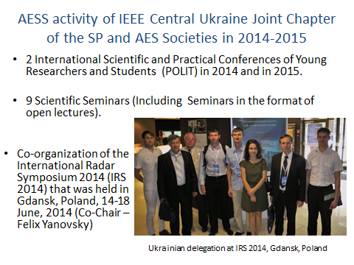

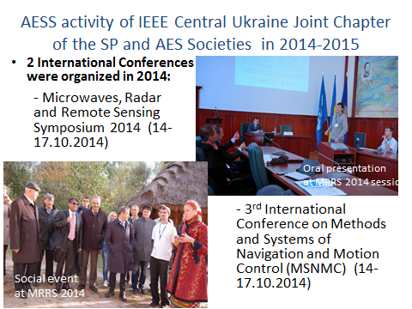 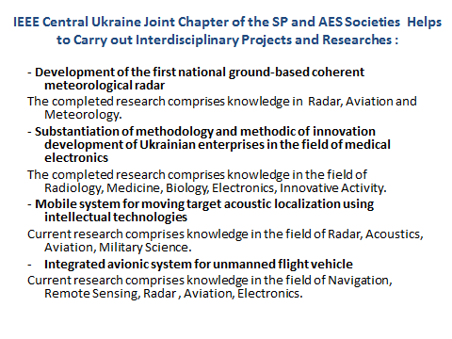

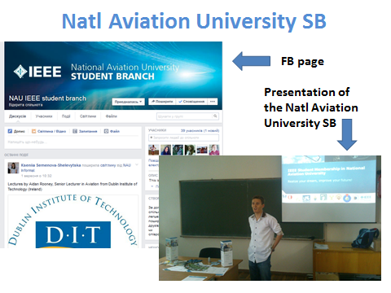 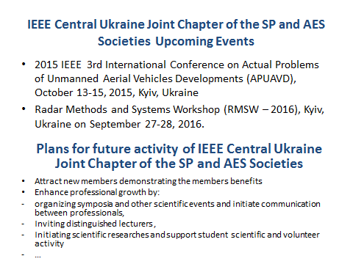

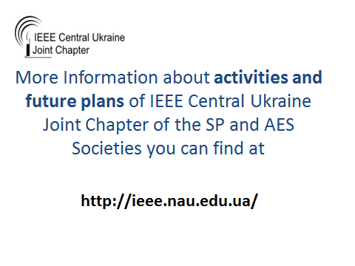

**AESS chapter activities in Denmark**

by Albena Mihovska

Report on 2014-2015 IEEE Activities of the IEEE-Denmark Joint Chapter VT06/AES10/IT12/COM19

During 2014, the IEEE-Denmark Joint Chapter on VT06/AES10/IT12/COM19 had a large number of activities in Denmark and internationally, aimed at promoting, creating awareness and at strengthening the IEEE cause.

**Meetings of Executive Board:**

The Executive Board of VT06/AES10/IT12/COM19 have convened five times to discuss the Chapter strategy. Also, during 2014, Albena Mihovska from CTIF, Aalborg University has been accepted as the Chapter Secretary to replace Petar Popovski and Lars Kierkegaard from Teracom has replaced Christian Kloch as a Chapter Member.

**Activities under the VT06/AES10/IT12/COM19 for the period 2014-2015:**

The Second Global Wireless Summit (GWS) was successfully organized and hosted in Aalborg under the umbrella of the VT06/AES10/IT12/COM19, in May 2014. GWS 2014 joined under the common theme “Green and Secure Information Communication Technology,” four renowned international conferences, - Wireless Vitae (which is the VT06/AES10/IT12/COM19 own conference), Prisms, IC5 and WWSMC. The conferences brought together academia, industry and standardization bodies into fruitful networking and discussions about novel and original research towards ICT globalization, including key aspects, such as energy and security in existing and future wireless technologies and enablers of smart cities and sustainable living and energy, which are also in line with the growth and development plans of Aalborg and North Jutland.

VT06/AES10/IT12/COM19 has been very active within WWRF activities, in particular, WG A of WWRF.

VT06/AES10/IT12/COM19, in cooperation with the Center for TeleInfrastruktur (CTIF), Aalborg University held a number of research seminars by Distinguished IEEE Speakers, such as Dr Sudhir Dixit from HP and Dr Seshadri Mohan.

On November 17-18, 2014, VT06/AES10/IT12/COM19 organized the conference on Mobile in Developing Countries, which was held in Copenhagen, Denmark, with about 60 participants.

The 1st International Workshop on Innovation and Entrepreneurship (IWIE) was organized jointly by the Center for TeleInfrastruktur, Aalborg University, NOVI Science and IEEE-Denmark Joint CH08337 VT06/AES10/IT12/COM19. IWIE was planned as a platform for undergraduate and graduate students, researchers, industries, government, private equities and venture capitalists to express their innovative potential through ideas and get the proper support for their commercialization as start-ups. One of the focus areas was AES.

**Further activity planned for 2015 is the Global Wireless Summit (**GWS 2015) to be held on December 13-15, 2015, in Hyderabad, India. AES is part of the GWS and has a prominent place in the IEEE Wireless VITAE 2015 conference.

**AESS chapter activities in Poland**

by Wojciech Krzystofik

**ANNUAL REPORT FOR YEAR 2014**

**IEEE MTT** SOCIETY; **AP** Society; **AES** Society

**Chapter Name:** 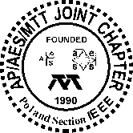 **AP/MTT/AES Joint Chapter**, **IEEE Poland Section**

**1. BASIC INFORMATION**

1. Section Name: **IEEE Poland Section**
2. IEEE Region Number: **8**
3. Societies that your chapter is joint with, if any: **MTT**, **AP** and **AES**
4. Chapter Web address, if any: [**http://sites.ieee.org/poland-apaemtt/sample-page/**](http://sites.ieee.org/poland-apaemtt/sample-page/)
5. Officers for 2014 and for 2015: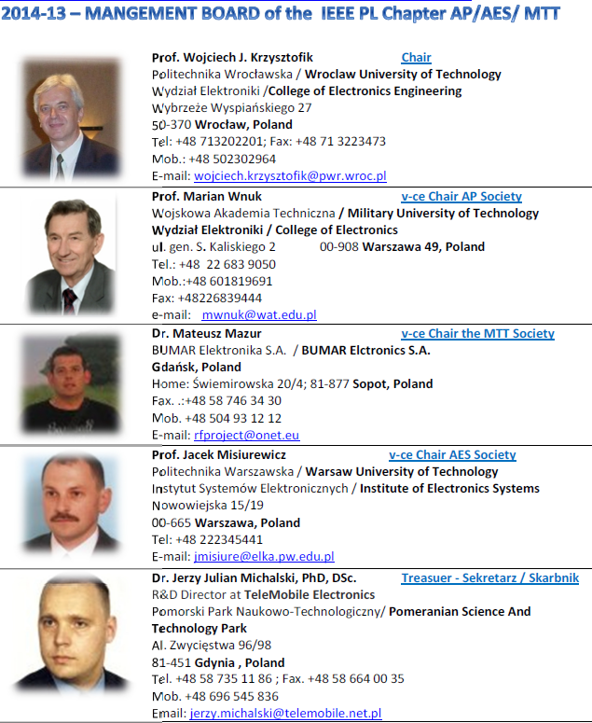



# 1.1 Chapter Membership and Membership Development

|  |  |
| --- | --- |
| Variable | Response |
| Regular, Associate and Affiliate members | as of Dec 31, 2014 | 80 |
| Regular, Associate and Affiliate members | as of Dec 31, 2013 | 80 |

# Student Grade Members

|  |  |
| --- | --- |
| Variable | Response |
| Student Grade Members | as of Dec 31, 2014 | 1 |
| Student Grade Members | as of Dec 31, 2013 | 0 |

# Fellows

|  |  |
| --- | --- |
| Variable | Response |
| Fellows | as of Dec 31, 2014 | 5 |
| Fellows | as of Dec 31, 2013 | 5 |

# Senior Members

|  |  |
| --- | --- |
| Variable | Response |
| Senior Members | as of Dec 31, 2014 | 11 |
| Senior Members | as of Dec 31, 2013 | 11 |

# Total membership

|  |  |
| --- | --- |
| Variable | Response |
| Total membership | as of Dec 31, 2014 | 97 |
| Total membership | as of Dec 31, 2013 | 96 |

**1.2.Chapter Members’ Achievements**

**Prof. Wojciech Gwarek**

* + 2005-2008 Distinguished Microwave Lecturer, IEEE MTT Society
  + 2011 IEEE MTT-S Pioneer Award

**Prof. Józef Modelski –**

* + 2008 President of the IEEE Microwave Theory and Techniques Society (MTT-S),
  + 2009-2010 Director of IEEE Region 8
  + 2013- Director of IEEE Division IV,
  + 2013 IEEE Distinguished Service Award

**Prof. Wojciech J. Krzysztofik**

* + 2012-2014 IEEE MTT-S R-8 Ambassador
  + 2011 IEEE Certficate of Appreciation

**2. FINANCIAL INFORMATION**

A. Chapter funds on 1 January 2014: (US $) **2 884,23;** (PLN) **1733,50**

B. Income (US $) during 2014:

1. Support from MTT\*: **1 000,00**
2. Support from other IEEE Societies: AP-S **1 650,00**

AES-S **300,00**

1. IEEE Section support **275,00**
2. Other support (specify):

Transfer of unused appropriations from the 2014-MIKON Conference (PLN) **7440,08**

TOTAL INCOME: (US $) **3225,00;** (PLN) **7440,08**

\* Include annual support, special-project support, travel grant support, Best Chapter Award support, and any other support from MTT.

C. Expenditures (US $) during 2014:

2014-MIKON Conference Fee (€) **400,00**

2014-MIKON Conference Prizes (US $) **983,77**

D. End of year balance (US $) as of 31 December 2014: (US $) **4 850,46**; (PLN) **8 336,98**

**3. CHAPTER ACITVITIES DESCRIPTION**

**(**This information is used in the selection of the Best Chapter Award).

**3.1 Summary Information for 2014**

# Meeting Plan for 2014

* Organization of the Technical Meetings all over the Poland country in Wroclaw, Gdansk, Warsaw, Cracow, etc. - the main research and academia centers.
* Invitation of the IEEE Societies as well as the local Distinguish Lectures and Instructors.
* Chapter’s flag Conference, organized biannually: the International Conference of Microwave Radar and Wireless Communication – MIKON 2014, Gdansk, Poland.
* Technical Workshop co-organized with the MIKON-2014 Conference, and by the academia.
* Attendance in the Regional Chapter Chairs Meetings
* Administrative Chapter Meetings: two stationary and more than 6 video-meetings by Internet
* Supporting the Doctoral Student to join the IEEE and organize the Workshops / Seminaries.
* Promotion of the members toward IEEE grade evaluation to Senior Member and Fellow.

**A. Number of technical meetings (in which a technical presentation is made)**

1. **Presentations from student members of your chapter: 4**
2. **Presentations from non-student members of your chapter: 2**

(A member of your chapter is one who belongs to the

MTT Society and who lives within your Section. Do not

include IEEE Distinguished Lecturers)

1. **Presentations from outside speakers: 1**

(This includes speakers from outside your chapter.

Do not include IEEE Distinguished Lecturers.)

1. **Presentations from IEEE Distinguished Lecturers: 5 (1 and 3-6 in Table)**
2. **TOTAL numbers of technical meetings: 12**

**B. Average total attendance at the technical meetings: 24 persons**

(Average over all of the technical meetings held during the year.)

**C.** **Number of non-technical (organizational) meetings held: 2**

* IEEE R8 Chapter Chairs meeting 17.06.2014 15:30, Gdansk, Poland
* Administrative AP/MTT/AES PL Chapter Meeting 29.10.2014, 10.20, Jachranka, Poland

**D. Number of workshops, short courses, or conferences organized or co-organized by your chapter: 2**

1. **Summary of Workshops, Short Courses, and Conferences for 2014**

Include below a list of each workshop, short course, or conference that was organized or co-organized by your chapter. Include the title of the event, the dates of the event, a description of the event, and an indication of the level of involvement of your chapter. Please be specific about the role of your chapter in the event.

**Workshop**:

* Title: “**Filter Design for Class-S Amplifiers**”

Presenters: **Kurt Blau**\*, Member IEEE, **Elena Serebryakova**#

\*RF and Microwave Research Laboratory, Technische Universität Ilmenau, Ilmenau, Germany

# QUNDIS GmbH, Erfurt, Germany

Place: room E (MARIACKA) Mercure Hotel Gdansk, Gdansk, Poland

Date:, Tuesday, 17 June 13:50, MIKON 2014

1. **Conference: Microwave Radar Week MRW2014,** in Gdansk, Poland, with two events:
2. **MIKON 2014** - Microwave Conference + Workshop
3. **IRS 2014** – International Radar Symposium

Conference WEB: <http://mikon2014.ire.pw.edu.pl/>

Date: **16-18.06.2014**

venue: Gdansk Mercure Hotel, Gdansk, Poland

* Technical co-sponsorship of MRW and MIKON 2014 by: **IEEE MTT-S, AP-S, AES-S**, EuMA, URSI, PAN, etc.
* Chairman and vice Chairmen’s of Conference, and the Organizing Committee were  **the members of Joint Chapter AP/AES/MTT, IEEE Poland Section**

**SUMMARY of MRW2014, Microwave Radar Week,**  Gdansk, Poland

**MIKON2014:**

* **186** participants, **85** from Poland, **101** foreigner participants
* **137** oral presentations (**31** Sessions – **27** regular) including **8** invited papers
* **56** poster presentations ( **3** Sessions)
* **1** Workshop

**IRS2014:**

* **141** participants,
* **3** Workshops
* ca. **80** oral presentations (**20** Sessions –) including **8** invited papers
* ca. **20** poster presentations ( 3 Sessions)
* **Young Scientist Contests**. Awards also from **IEEE MTT-S**, EuMA, …
* **12** Exhibitors
* **1** Workshop
* Exhibitors presentations
* **2** IEEE MTT-S Region 8 Chapter Chairs & Ambassadors Meetings
* **2** social events.

Citation from welcome note written by professor Michał Mrozowski Chair of Mikon 2014:

“…*Ever since the MIKON conference has become an international event, it has attracted a growing number of microwave engineers from all over the world. This year, we received over 200 submissions from 33 countries, including 48 from Ukraine, 14 from Turkey, 14 from Germany, 6 from Italy, and 4 from the USA, Korea and Russia. With these numbers, we are happy to see that MIKON has established itself as a truly international event.*

*Although the turbulent situation in Ukraine forced us to move the conference from Lviv to Gdansk, this last-minute change did not have an adverse effect on submissions.*

*The conference program is composed of 137 talks and 55 poster presentations. There will be 3 special sessions with invited presentations, including one joint MIKON/IRS session on space technologies, 1 focused Polish–Italian session on space research, 27 regular oral sessions, 3 poster sessions, and a workshop on filter design for class S amplifiers. The conference is accompanied by an exhibition and a series of company presentations. The invited presentations—8 of which will be given during plenary sessions and 5 as introductions to regular sessions—provide state-of-the art views of various aspects of microwave engineering. A notable topic in the conference presentations is the application of microwave technology to space exploration and space research. It is MIKON’s tradition to hold a Young Authors’ Contest. This year we have a record number of candidates and a commensurate number of prizes sponsored by the Polish Academy of Sciences, the IEEE MTTs, the European Microwave Association (EuMA), and the GAAS Association. I would like to thank all these organizations for their support. Thanks to their generosity, we can better appreciate the efforts of the many young authors for whom MIKON is often the first step in their professional career. …”*

Photo Gallery from **MRW2014, Microwave Radar Weeek 2014,**  Gdansk, Poland

|  |  |  |
| --- | --- | --- |
| DSC03236 Opening Session | DSCF6353 YSC Awarding ceremony | DSC03516 Awarding for best diploma thesis during Banquet |
| DSCF6313  Exhibitors | DSC03534  Session | DSC03565  Barbeque |

**3.2 Technical Meeting Information for 2014**

Note: For “Category”, please use the following:

S: speaker is a student member of the chapter

M: speaker is a non-student member of the chapter (but do not include IEEE Distinguished Lecturers)

O: speaker is from outside the chapter (but do not include IEEE Distinguished Lecturers)

D: speaker is an IEEE Distinguished Lecturer.

|  |  |  |  |  |  |
| --- | --- | --- | --- | --- | --- |
|  | **Title of Presentation/Name of Speaker, Affiliation/Place/Date** | **Attendance**  **IEEE Other Total** | | | **Category** |
| **1** | *"****QFN-based Packaging Concepts for Millimeter Wave Transceivers****". prof.* ***Thomas Zwick (MTT DML 2013-2015)****, Karlsruhe Institute of Technology, Karlsruhe Baden-Wuerttemberg 76128,* ***Germany,*** *Place:* ***Gdansk University of Technology,*** *Gdansk, Poland,* ***26 March*** *2014, Time 3-5 PM* | **5** | **15** | **20** | **D** |
| **2** | ***„An algorithm for a lossless compression of raw radar data”****, Dr.* ***Bartosz Pikacz****, Warsaw University of Technology, Place: Warsaw University of Technology,* ***Warsaw****,* ***Poland, 26 March*** *2014, Time 12AM-2 PM* | **12** | **3** | **15** | **M** |
| **3** | ***„Inkjet-Printed Nanotechnology-Enabled RFID, Internet of Things and "Zero-Power" Wireless Sensor Nodes”****, prof.* ***Manos Tentzeris,***  ***(MTT DML 2010-2012)****,**Georgia Institute of Technology, Atlanta, GA 30332-250, U.S.A, Place: Gdansk University of Technology,* ***19 June*** *2014,* ***Gdansk****,* ***Poland****, Time: 12AM-2PM* | **7** | **26** | **33** | **D** |
| **4** | ***„Inkjet-Printed Nanotechnology-Enabled RFID, Internet of Things and "Zero-Power" Wireless Sensor Nodes”,*** *prof****. Manos Tentzeris****,* ***(MTT DML 2010-2012)****, Georgia Institute of Technology, Atlanta, GA 30332-250, U.S.A, Place: Wroclaw University of Technology,* ***24 June*** *2014,* ***Wroclaw, Poland,*** *Time: 1-2PM* | **8** | **18** | **26** | **D** |
| **5** | ***„Inkjet-Printed Nanotechnology-Enabled RFID, Internet of Things and "Zero-Power" Wireless Sensor Nodes”,*** *prof.* ***Manos Tentzeris****,* ***(MTT DML 2010-2012)****, Georgia Institute of Technology, Atlanta, GA 30332-250, U.S.A, Place AGH University of Science and Technology,* ***25 June*** *2014,* ***Cracow, Poland****, Time: 11AM-1PM* | **10** | **31** | **41** | **D** |
| **6** | ***„Inkjet-Printed Nanotechnology-Enabled RFID, Internet of Things and "Zero-Power" Wireless Sensor Nodes”,*** *prof.* ***Manos Tentzeris****,* ***(MTT DML 2010-2012)****, Georgia Institute of Technology, Atlanta, GA 30332-250, U.S.A,**Place:* ***Warsaw University of Technology, 26 June*** *2014,* ***Warsaw, Poland,*** *Time: 12AM-2PM* | **10** | **15** | **25** | **D** |
| **7** | ***„Design and Investigation of Modern Antenna based on Metamaterials and Fractal Geometry”****, PhD Stud.,* ***Thanh Nghia Cao,*** *Vinh University in Vietnam, Place: Wroclaw University of Technology,* ***29 October*** *2014,* ***Wroclaw, Poland,*** *Time: 11AM-2PM* | **5** | **13** | **18** | **S** |
| **8** | ***„Electromagnetic Field Meter Calibration - what is the Calibration Result?”****, PhD Stud. Bartlomiej Zubrzak, Wroclaw University of Technology, , Place: Wroclaw University of Technology,* ***05 November*** *2014,* ***Wroclaw, Poland,*** *Time: 11AM-2PM* | **7** | **14** | **21** | **S** |
| **9** | ***„Modular, software-defined platforms for measuring and processing high-frequency signals in telecommunication and measurement-related applications”,*** *dr.* ***Maciej Antonik****, National Instruments Eastern Europe, Wroclaw, Poland, Place: Wroclaw University of Technology, 12 November 2014,* ***Wroclaw, Poland,*** *Time: 11AM-1PM* | **6** | **18** | **24** | **O** |
| **10** | ***„Controlled Interaction of Electromagnetic Field on Biological Objects”****, PhD Stud.* ***Pawel Cala****, Wroclaw University of Technology, Place: Wroclaw University of Technology,* ***12 December*** *2014,* ***Wroclaw, Poland,*** *Time: 11AM-1PM* | **7** | **18** | **25** | **S** |
| **11** | ***„150th Birthday of the Four Equations that Changed the World, that is Good with the Now Defunct Ether”,*** *prof.* ***Michal Mrozowski, IEEE MTT Fellow****, Gdansk University of Technology, Place: Gdansk University of Technology,* ***08 December*** *2014,* ***Gdansk****,* ***Poland****, Time: 12AM-3PM* | **20** | **150** | **170** | **M** |
| **12** | ***„Implementation of selected real-time services in sensor networks with multiple-hop”****, PhD. Stud.,* ***Pawel Bardowski****, Wroclaw University of Technology, Place: Wroclaw University of Technology,* ***10 December*** *2014,* ***Wroclaw, Poland,*** *Time: 11AM-1PM* | **5** | **16** | **21** | **S** |

**3.3 Special Projects**

Give a description of any special projects that your chapter participated in during the year, and indicate any funding that was obtained from MTT or other sources. If possible, indicate how your chapter was improved as a result of the special project.

 ,

[20th International Conference on Microwaves, Radar, and Wireless Communications, 16-18 June,](http://mikon2014.ire.pw.edu.pl/index.php/Final_paper_preparation_and_submission) (see below)

1. **Organizing IEEE MTTs R8 chapters meeting during MRW2014.** 17.06.2014 15:30-17:30, Gdańsk

* it was notified in the 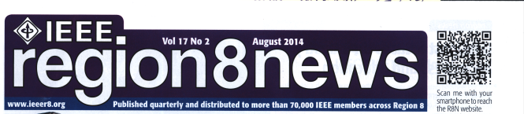

[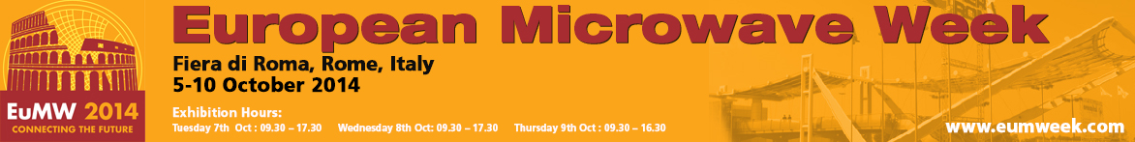](http://www.eumweek.com/archive/eumweek2014/www.eumweek.com/index.html)

1. **Region 8, MTT-S Chapter Chairs and Ambassador Meetings on October 6, 2014.**

|  |  |
| --- | --- |
| DSC01025 | DSC00995 |

**3.4 DESCRIPTION OF OTHER ACTIVITIES**

(This information is used in the selection of the Best Chapter Award)

**150th Birthday Maxwell's Equations** organised by prof. Michał Mrozowski **(***Fellow Member, our Past Chapter Chair***).**

December 8 is the 150th anniversary of [James Clerk Maxwell](http://en.wikipedia.org/wiki/James_Clerk_Maxwell)’s presentation on electromagnetic theory to the Royal Society in London.

**Date:** 8.12.2014, 12:30

**Place:** Gdańsk University of Technology, Auditory Room 2 EA.

**Programme:**

* **Lecture by Prof. Michał Mrozowski :** *„150 urodziny czterech równań, które zmieniły świat, czyli o pożytku z nieistniejącego eteru”* ***“(eng.) 150th Birthday of four Maxwell's Equations that have changed our Word – about advantages of non-existent ether.”***
* **Maxwell 2014 awards Ceremony**
* **Other awards for attendees and surprise**
* **The Event was transmitted via Youtube ( over 500 enteries)**
* **Over 200 attendees at place.**
* The Event was transmitted via Youtube <https://www.youtube.com/watch?v=MWC-1ILspOA> ( > 500 enteries)
* Also available on : [**https://www.facebook.com/eti.mwave?ref=stream**](https://www.facebook.com/eti.mwave?ref=stream)

|  |  |
| --- | --- |
|  |  |

# 3.5 Participating in Regional and/or Societies´ Technical Programs

# Prof. Wojciech Krzysztofik, Chapter Chair / R8 MTT-S Ambassador

# was invited as Keynote Lecturer, presenting the lecture “Fractal Geometry in the Antenna Technology of Modern Communications”

on the 2nd IEEE Workshop on “**Advances in Information, Electronic and Electrical Engineering**”, organized by Lithuania and Latvia IEEE Sections on 28-29 November 2014, in **Vilnius Gediminas Technical University**, Vilnius, **Lithuania.**

# Prof. Wojciech Krzysztofik, Chapter Chair / R8 MTT-S Ambassador

# was invited as Keynote Lecturer, presenting the lecture “Fractal Geometry in the Antenna Technology of Modern Communications”

on the Meeting organized by Joint Chapter AP03/MTT17/ED15, IEEE Finland Section, on **1 December 2014** in **Aalto University of Technology**, Espoo, **Finland**

**4. Educational Activity**

# 4.1 Accrual of Practical Benefits for Local Chapter Members

# 4.2 Distinguished Lecturers, Regional Speakers, Industrial and Other Speakers Sponsored by the Chapter

1. Date: 26 March 2014, 3-5 PM,

***Speaker:*** *prof.* ***Thomas Zwick,*** *Karlsruhe Institute of Technology,* Karlsruhe Baden-Wuerttemberg 76128, *Germany, MTT Distinguished Microwave Lecturer* ***(Term: 2013-2015)***

*Title: "****QFN-based Packaging Concepts for Millimeter Wave Transceivers****".*

***Location:*** *Gdansk University of Technology, Faculty of Electronics, Telecommunication & Informatics, Gdansk, Poland*

|  |  |
| --- | --- |
|  |  |

1. 4 – times DML Lecture on dates: **19 June** 2014, 12AM-2PM, **Gdansk**, Poland; **24 June** 2014, 1-3PM, **Wroclaw**, Poland; **25 June** 2014, 11AM-1PM, **Cracow**, Poland; **26 June** 2014, 12AM-2PM, **Warsaw**, Poland

**Speaker:** prof. **Manos Tentzeris** , Georgia Institute of Technology, Atlanta, U.S.A.

MTT Emeritus Distinguished Microwave Lecturer **(DML Term: 2010 - 2012)**

Title: "**Inkjet-Printed Nanotechnology-Enabled RFID, Internet of Things and "Zero-Power" Wireless Sensor Nodes** ".

**Locations:** Gdansk & Wroclaw & Cracow & Warsaw Universities of Technology, Faculty of Electronics, Telecommunication & Informatics, Gdansk, Wroclaw, Cracow, Warsaw, Poland

|  |  |
| --- | --- |
| DSC00767 | M |

1. Date: 8 December 2014, 12AM-3 PM,

**Speaker:** prof. **Michal Mrozowski,** Gdansk University of Technology, Gdansk, Poland, IEEE MTT Fellow **(Term: 2008)**

Title: "**150th Birthday of the Four Equations that Changed the World, that is Good with the Now Defunct Ether**".

Gdansk University of Technology, Faculty of Electronics, Telecomm. & Informatics, Gdansk, Poland

1. Founded Four Awards , called “Maxwell 2014” for the Best Students in EM Theory, and
2. the 6-other Awards for attendees and surprise – Big Layer Cake with Four Maxwell equations

The Event was transmitted via Youtube <https://www.youtube.com/watch?v=MWC-1ILspOA> ( > 500 enteries)

Also available on : [**https://www.facebook.com/eti.mwave?ref=stream**](https://www.facebook.com/eti.mwave?ref=stream)

December 8, is the 150th Anniversary of [James Clerk Maxwell](http://en.wikipedia.org/wiki/James_Clerk_Maxwell)’s First presentation of electromagnetic theory to the Royal Society in London .

**4.2. Were there any unique or innovative activities within your chapter?**

Some possibilities that you might want to include are:

* Collaboration with other IEEE societies and chapters
* Student involvement and new member recruitment
* Interaction with industry or the community
* Educational activities

# Awards for young scientist founded biannually by the Chapter

On the occasion of [20th International Conference on Microwaves, Radar, and Wireless Communications, 16-18 June,](http://mikon2014.ire.pw.edu.pl/index.php/Final_paper_preparation_and_submission) Chapter has been founding biannually

* **Awards for the Best Diploma MSc Thesis (2012-2014),**in the topics of microwaves, antennas, and radar technology .

**4.3. Miscellaneous information, elaboration on any of the above topics, or special factors to be considered.**

List of innovative membership development programs/activities / results of the Chapter:

1. The glass-cases are situated in our Institutions, where IEEE news are published.
2. Chapter has regularly organized ”**Regional Seminary on Antennas, Microwave & Mobile Communications**”, together with Sections of Microwaves & Radar, the Polish Academy of Science, in three of our main academy cites, namely: Warsaw, Wroclaw and Gdansk.
3. The Chapter activities are regularly **(twice a year)** presented to the larger audience during **the Polish Academy of Science, at the Committee of Microwave and Radiolocation Meetings,**
4. The Chapter co-organized the two International Conferences,
5. Many Technical Meeting organized by the Chapter collected people from different areas of technical activities: the Academia, the Industry as well as many young students.
6. Collaboration with other IEEE societies and chapters. We are the JOINT Chapter of three Societies, namely: Antennas and Propagation Society, Aerospace Electronic Systems Society and Microwave Theory and Techniques Society, our activities are spreads all over these communities. It takes different forms, staring from yearly attention of Chapters Chairs Meeting, throughout permanent invitation of speakers as well as the guest of our Seminary Meeting from different areas of our specializations.
7. We have current collaboration(common technical meetings, exchange the visitors) with Poland Chapters of EMC and Photonic Societies.

, and 

1. We have a group of active students called “Wireless Group”, who collaborate with IEEE Student Branch affiliated to our Chapter.
2. **SUGESSTIONS FOR MTT/AP/AES**

* It will be very helpful if the basic IEEE Advertising materials will be delivered every year to a new Chapter Officers, or the way how it could be achievable were indicated.
* The IEEE Website should be available in TWO versions: 1) extremely simple for common users, and 2) with full possibilities for most expertised and administrative.

**6.May this report be posted on the MTT-S, AES-S, and AP-S Chapters web page or disseminated by other means (Yes/No)? YES**

**I verify the correctness of all data of this completed Form.**

# Name / Sign of Chapter Chair: PODPISWJK_tif

# Date of Submitting: January 10, 2015

|  |  |  |  |
| --- | --- | --- | --- |
| **AESS chapterchairs** | **Email address** | **country** | **remarks** |
| Heinz Wipf | heinz\_wipf@bluewin.ch | Switzerland | Reported |
| Mats Edvinsson | mje@ieee.org | Sweden | Reported |
| U. Burnik | urban.burnik@ieee.org | Slovenia | Reported |
| V. Markovic | vera.markovic@elfak.ni.ac.rs | Servia | No chapter |
| Lupco Karadzinov | l.karadzinov@ieee.org | Macedonia | No chapter |
| Rafel Sliz | rafel.sliz@ee.oulu.fi | Finland | No chapter |
| Kalle Tammemae | kalle.tammemae@ieee.org | Estonia | No respons |
| Ramjee Prasad | prasad@es.aau.dk | Denmark | Reported |
| Felix Yanovsky | yanovski@i.com.ua | Ukraine | Reported |
| Mircea Eremia | eremia1@yahoo.com | Romania | No respons |
| Rositza Goleva | rig@tu-sofia.bg | Bulgaria | No respons |
| Matej Pacha | matej.pacha@ieee.org | Ceskolovenska | No chapter |
| Wojciech Krzysztofik | wojciech.krzysztofik@pwr.wroc.pl | Poland | Reported |
| Mark Bentum | m.j.bentum@utwente.nl | Benelux | Reported |
|  |  |  |  |
| 14 Eu countries |  |  |  |
| 7 reports |  |  |  |
| 4 no chapters |  |  |  |
| 3 no respons |  |  |  |