History Committee-AESS IEEEGHN Oral Histories

Jim Leonard and Barbara Johnston

We have looked at the GHN website for Oral Histories and found that there are 81 Individuals listed under Aerospace & Electronics Systems Society: We have listed the first 10 and a few known others

- Henry Oman
- Warren Cooper
- Myron Kayton
- Cary Spitzer
- Merrill Buckley
- Karl Astrom
- Stanley A. White
- Ivan getting
- Thelma Estrin
- Dimitri Grabbe
- Sajj Durrani
- Merrill Skolnik
- John Gregory
- John Guarrera
- Joel Snyder
- Henry Bachman
- David Middleton

If one goes to the website: www.ieeeghn.org/wiki/index.php and searches on the keyword
“Aerospace & Electronics Systems Society, the 81 names will pop up. By clicking on their name, you will see a transcript of the interview. By clicking on the microphone symbol, you will be able to listen to the voice of the interviewee.

History of AESS

If one is interested in the history of the formation of the AES Society and its SYSTEMS magazine, please refer to the December 2010 issus of SYSTEMS magazine. Page over to the INDEX section then two more pages in and one will find two pages of History provided by our outspoken by our Adm Editor, Dave Dobson (LSM).

Background: IEEE was formed in 1963 by the amalgamation of IRE and AIEE. The page showing the AES Society heritage begins in 1940 with the AIEE Air Transportation Committee. The SYSTEMS magazine had its origin with the “MIL-E-GRAM” or Monthly newsletter of the Military Electronics Group of the IRE.

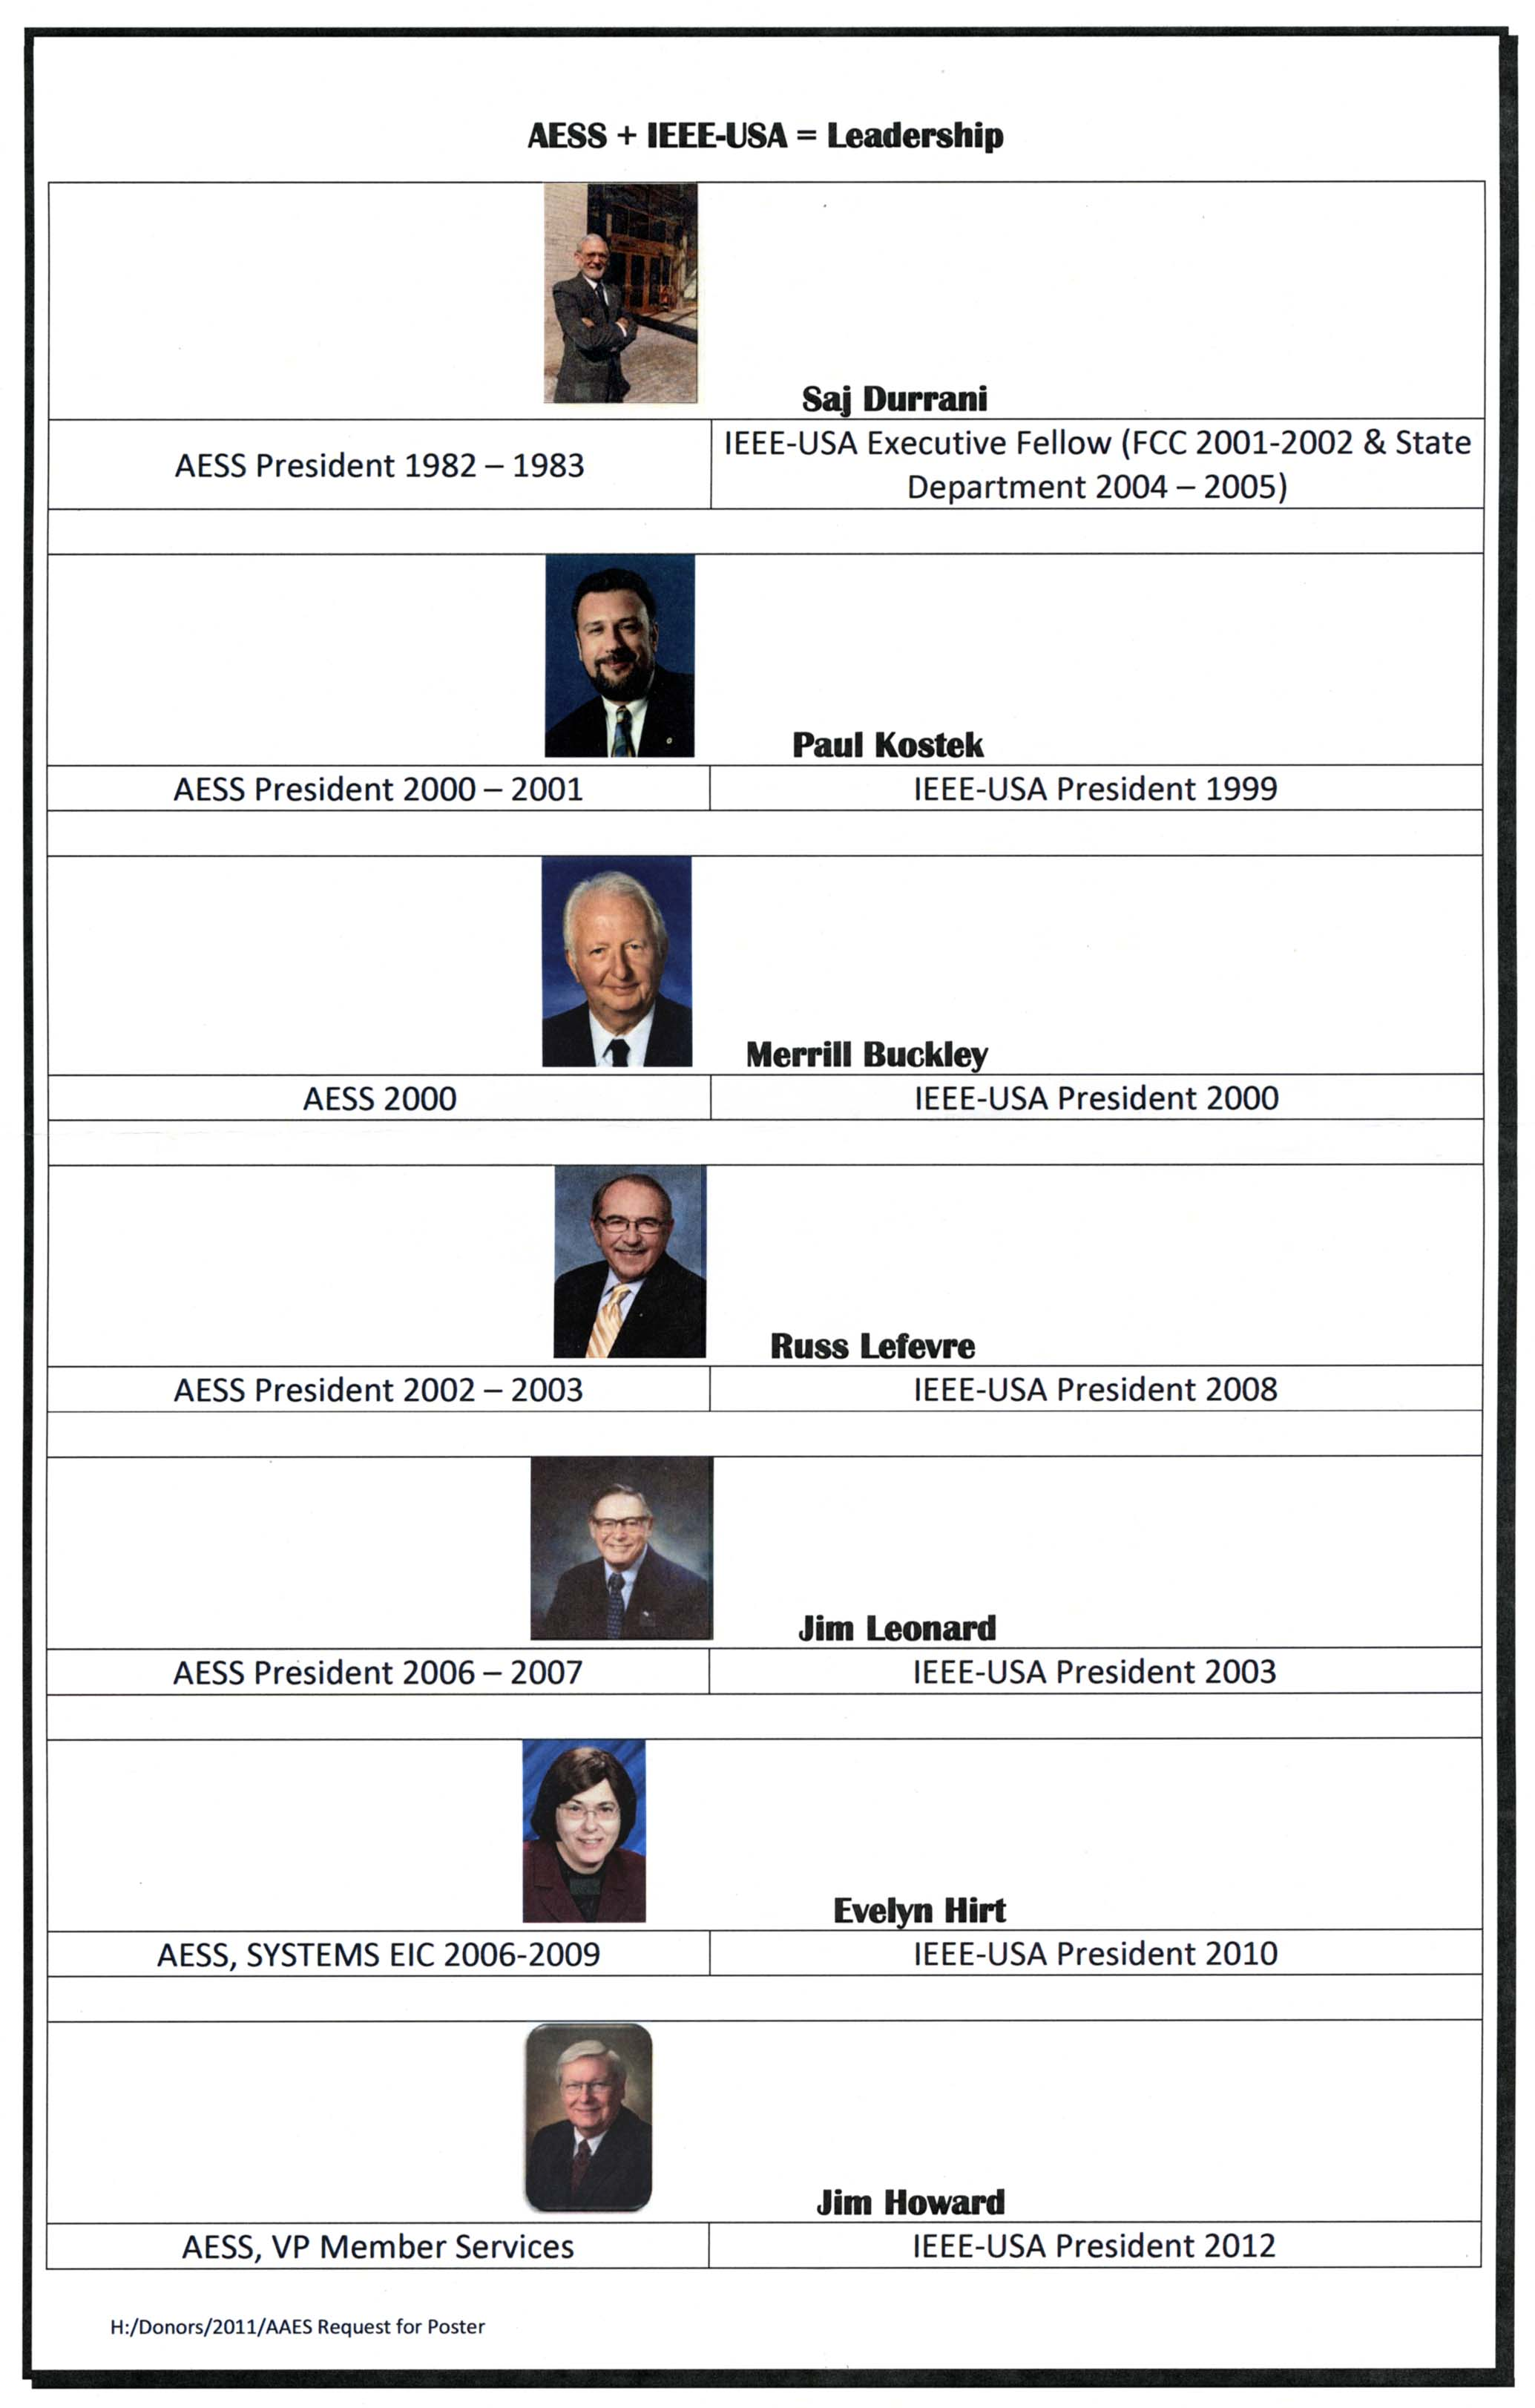
LEGACY OF THE AES SOCIETY AND IEEE-USA

If one takes a look at the volunteers that have served as President of the AES Society and IEEE-USA, we have a great legacy. This was pointed out by Sajj Durrani recently. And the outcome resulted in a poster at the 2011 IEEE-USA Annual Meeting on 3-6 March, 2011 at Austin, Texas.

This poster (on the previous page) was placed at the AESS Booth at the meeting to commemorate this legacy. For the past five years, AESS has hosted a booth at the Annual IEEE-USA Meeting. Past copies of the SYSTEMS Magazine and past Tutorial Issues are handed out to the attendees.. The purpose is to demonstrate to the IEEE Members that there are IEEE publications that are of important and practical interest to our members working in industry.

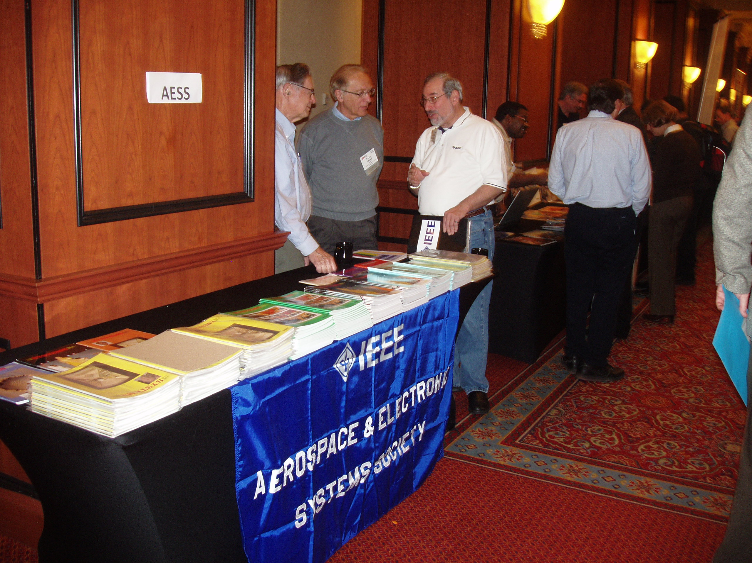

AESS BOOTH AT THE IEEE-USA ANNUAL MEETING

Again this year, I manned the AESS Booth at the 2011 IEEE-USA Annual meting held in Austin, Texas, on 3-6 march 2011. Plans for 2012 are for holding the event at Cincinnati, Ohio, near Wright-Patterson Air Force Base on 3-6 May 2011. We again will host a booth

IEEE HISTORICAL MILESTONES

IEEE Milestones in Electrical Engineering and Computing
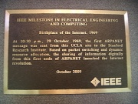
Program Guidelines: The IEEE Milestones in Electrical Engineering and Computing program honors significant technical achievements in areas associated with IEEE. It is a program of the IEEE History Committee, administered through the IEEE History Center. Milestones recognize the technological innovation and excellence for the benefit of humanity found in unique products, services, seminal papers and patents. Milestones are proposed, nominated, and sponsored by an IEEE Organizational Unit (OU)—such as an IEEE section, society or chapter. After recommendation by the IEEE History Committee and approval by the IEEE Board of Directors, a bronze plaque commemorating the achievement is placed at an appropriate site with an accompanying dedication ceremony. The program is administered for the IEEE History Committee by the IEEE History Center.
IEEE established the Milestones Program in 1983 in conjunction with the 1984 Centennial Celebration to recognize the achievements of the Century of Giants who formed the profession and technologies represented by IEEE.
Each milestone recognizes a significant technical achievement that occurred at least twenty-five years ago in an area of technology represented in IEEE and having at least regional impact. To date, more than a hundred Milestones have been approved and dedicated around the world.
It is a two-step process. You will first have to propose the idea. Your proposal will then be evaluated and the decision will be made on whether or not to invite you to make the full nomination.
However, before proceeding any further, please read the Proposing a Milestone page for guidelines and more detailed information. Also, please check the list of Milestones already in the proposal stage and the list of Milestones already in the nomination stage to make sure your intended milestone is not already in the process of being approved.

Special Citations
The IEEE History Committee also administers a special citation program to recognize events or institutions which – although not technical achievements as defined by the Milestone Program – have contributed to the profession. Examples might be: museums or archives with substantial holdings pertaining to the history of electrical engineering and computing, the holding of a seminal conference, or the formation of a technical society.
The IEEE Special Citation in Electrical Engineering and Computing works within the IEEE Milestones Program, and is administered similarly. The proposal and nomination process are the same. When proposing a special citation, please include the words “Special Citation” in the title of your proposal, e.g. “Museum of History of Electronics, Special Citation.” Please use a comma rather than a hyphen, colon, or semicolon in the title because the special characters affect the wiki code.

AESS SUPPORTED MILESTONES

 | Feature Article

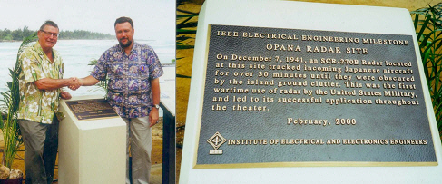
OPANA RADAR SITE DESIGNATED AS AN IEEE HISTORICAL MILESTONE
By Jim V. Leonard & Barbara Johnston
On 23 February 2000, the Opana Radar Site was designated as an IEEE Historical Milestone. The IEEE Historical Milestone Plaque was installed in a small park on the grounds of the Turtle Bay Hilton, Kuhuku, Hawaii. This event was the culmination of over 12 years of effort by many dedicated IEEE members. Their efforts are highlighted below.
In 1988, the first application to the IEEE History Center was submitted. When considered by the IEEE History Committee in 1990, it was turned down because it (the RADAR) "didn’t work". But, in reality, it did work! The Westinghouse-built SCR-270B RADAR was set up on the Opana Peak on the North Shore of Oahu. It was being operated by two U.S. Army Privates: Joe Lockhart and George Elliott. At about 0700 hours on 7 December 1941, they tracked and plotted the course of the incoming Japanese aircraft for about one-half hour. They phoned in their report to a temporary information center at Fort Schafter. The Lieutenant on duty told them to "Forget it, don’t worry about it." He thought it was a flight of B-17’s coming in from California. The fact that the U.S. Army did not respond to the warning given by this RADAR was not because the RADAR didn’t work, it was because the U.S. Army did not have the proper procedures in place to take advantage of this of this new technology marvel.
At the request of the Hawaii Section IEEE in 1999, Paul Kostek [then President of IEEE-USA and President-Elect of the Aerospace and Electronics Systems Society (AESS)], sent out a broadcast email in search of a volunteer to assist the Hawaii Section with their efforts to have the Opana RADAR Site designated an IEEE Historical Milestone. Jim Leonard, a member of the AESS Board of Governors, volunteered for the assignment. Leonard contacted Fred Kobashikawa, Hawaii Section Chair, for background information, and also George Curtis, the history chairman of the Hawaii Section, who had helped to prepare the paperwork for the original 1988 proposal.
After preparing the necessary application documents, Leonard took them to the AESS Board of Governors meeting in San Antonio, Texas, on 1 September 1999. There, the AESS BoG discussed the proposal. Professor Ed Reedy, Georgia Tech, a long time RADAR expert and Senior Past President of AESS, stated that the SCR-270B was on the leading edge of technology during this era. Leonard then met with Fred Kobashikawa and Paul Kostek at the IEEE-USA Professional Development Conference in Dallas, Texas. Leonard and Kobashikawa signed the forms, Paul Kostek signed the accompanying letters, and all were submitted to Mike Geselowitz, Director of the IEEE History Center.
Leonard called the Turtle Bay Hilton to request space for an IEEE Historical Plaque next to the National Parks Service Plaque. The National Parks Plaque features storyboard relating to the infamous events of 7 December 1941. Hotel General Manager, John G. Elford, agreed to Leonard's request. He also suggested that Dan Martinez, responsible for the Arizona Memorial and one who helped with the National Parks Plaque, be contacted. Martinez explained that the markers were placed on the grounds of the Turtle Bay Hilton because the actual site is being used for a Regional Relay Facility for Diplomatic Communications and is off limits to the public.
The IEEE History Committee met at IEEE Sections Congress '99 in Minneapolis, Minnesota, on 9 October 1999 to finalize the wording on the plaque. Committee members Charles R. Wright and John Martin worked with Leonard jotting down ideas and wordsmithing until a final text was agreed upon:

OPANA RADAR SITE
On December 7, 1941, an SCR-270B RADAR located at this site tracked incoming Japanese aircraft for over 30 minutes until they were obscured by the island ground clutter. This was the first wartime use by the United States Military, and led to its successful application throughout the theater.
February, 2000
Mike Geselowitz took the application with the above wording to the IEEE Board of Directors meeting in November at Snowmass, Utah. The IEEE Board of Directors approved the application and Gesleowitz sent an official IEEE letter to Fred Kobashikawa informing him of the Opana RADAR Site's designation as an IEEE Milestone in Electrical Engineering and Computing. A copy of this letter appears in the January 2000, issue of SYSTEMS magazine
Leonard paid a special visit to Capitol Hill in early December to meet with the legislative assistants of the two Senators and two Congressmen from Hawaii. Legislative Assistant Ann Stewart, from Congresswoman Patsy Mink’s office, furnished Leonard with a letter from the Congresswoman commending the IEEE for designating the site. Jim read this letter during his dedication speech on 23 February 2000.
At the same time, Leonard requested -- through the office of his Congressman, Jim Talent, Second District of Missouri -- that an American Flag be flown over the United States of America Capitol Building on 7 December 1999, in commemoration of the IEEE designation of the Opana RADAR Site as an IEEE Historical milestone. Kara Vlasity, legislative assistant to Congressman Talent executed the request. The American Flag was presented to Fred Kobasikawa, representing the Hawaii Section, at the Hawaii Council of Engineering Societies National Engineers Week Banquet, 25 February, 2000 in Honolulu, Hawaii.
The ceremony to dedicate the Opana RADAR Site as an IEEE Historical Milestone was held at the Turtle Bay Hilton on 23 February 2000 commencing at 10:00 AM. Hilton manager John Elford arranged for a concrete pedestal to be set in the ground to the left of the storyboard. The IEEE plaque is mounted upon this pedestal. He also arranged for seating at the small park area on hotel grounds and provided refreshments. Fred Kobashikawa was the master of ceremonies. He introduced the event and provided the agenda. Jim Leonard then made the dedication speech. He was followed by Stephen Johnston (IEEE, RADAR Engineer, Historian) who related the events of the day and subsequent history of RADAR in WW II. With the aid of Paul Kostek (President of AESS) and Cleon Anderson (IEEE Director Region 6), Mr. John Elford unveiled the plaque. This was followed by remarks by Bill Slattery (IEEE RADAR Engineer) whose father had worked on the early development of RADAR prior to WWII. George Curtis, Hawaii Section Historian, then made a few remarks about the earlier attempt to make this an IEEE Historical Milestone. He thanked Jim Leonard for making the second try a success.
Following the ceremony, a small group of IEEE members were taken up to the actual site by U.S. Navy Chief David Dettor. They were told not to take pictures of the facility. They did, however, take photos of the marker, looking in the direction of the sea. 23 February 2000, is a memorable date for the Hawaii Section and plans are in the offing to make this an annual celebration.

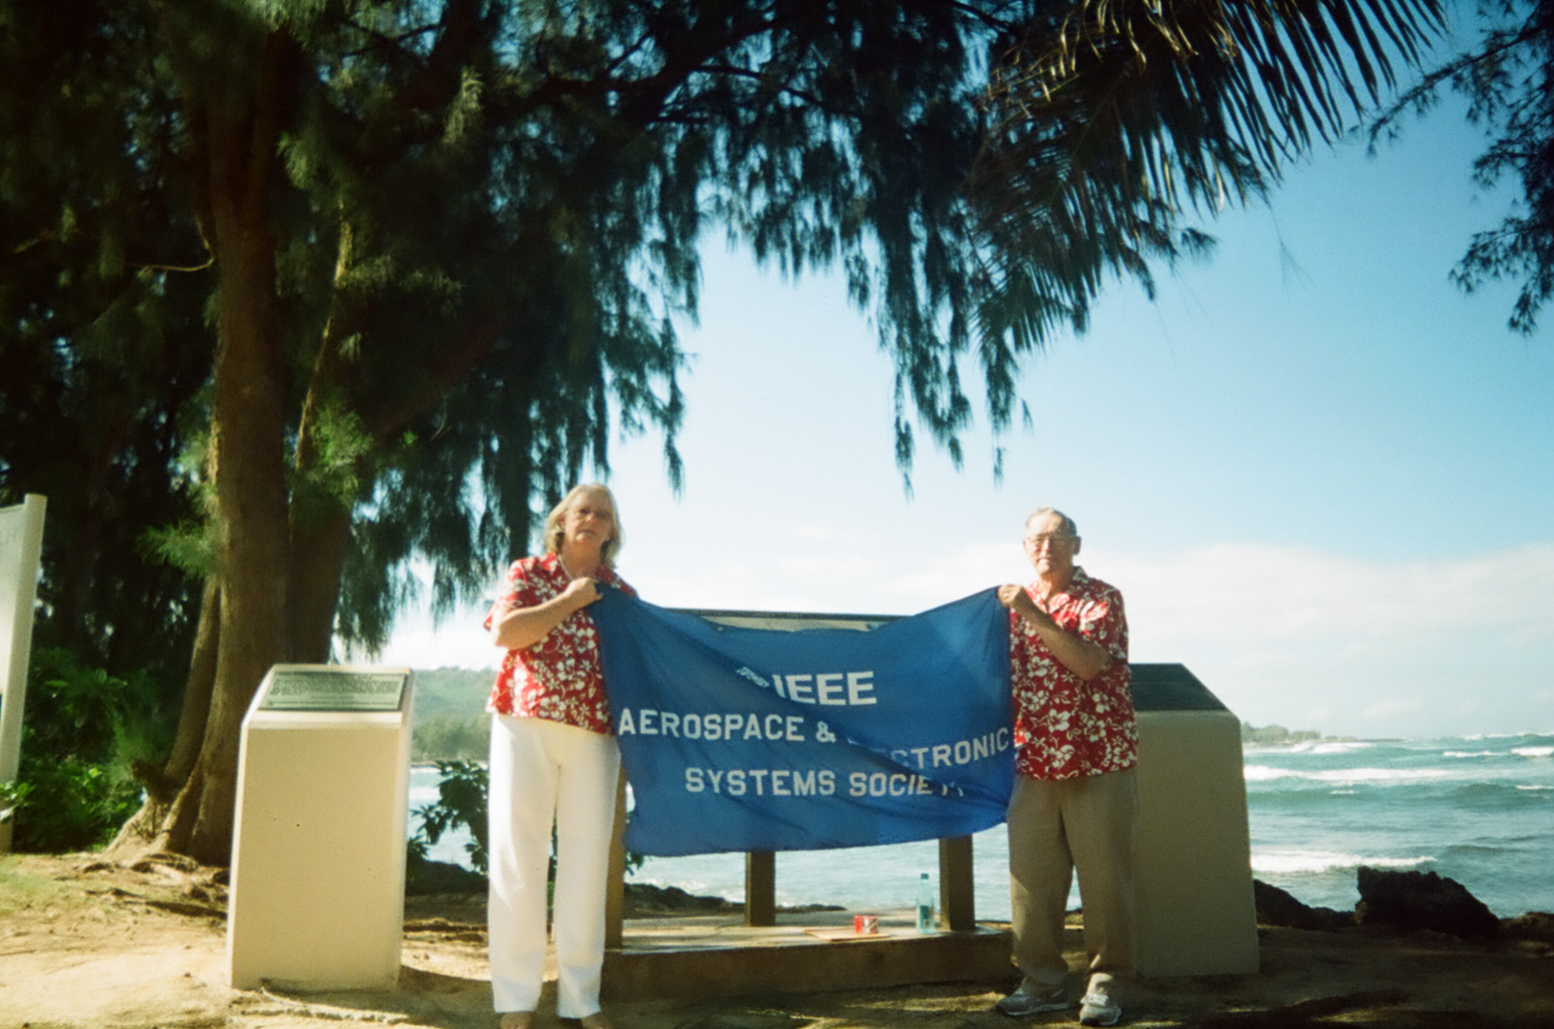
BARBARA JOHNSTON AND JIM LEONARD HOIST THE AESS BANNER AT THE OPANA RADAR SITE IEEE HISTORICAL MILESTONE ON JANUARY 14, 2010
Barbara Johnston and Jim Leonard revisited the IEEE Milestone at the Turtle Bay Resort on January 14, 2010, as part of their annual vacation to Hawaii. The Hawaii IEEE Section was contacted and Jim spoke with Fred Kabashikawa while there.
The actual site of the SCR-270B RADAR was at the top of Opana Peak, which is just below Barbara’s right elbow.
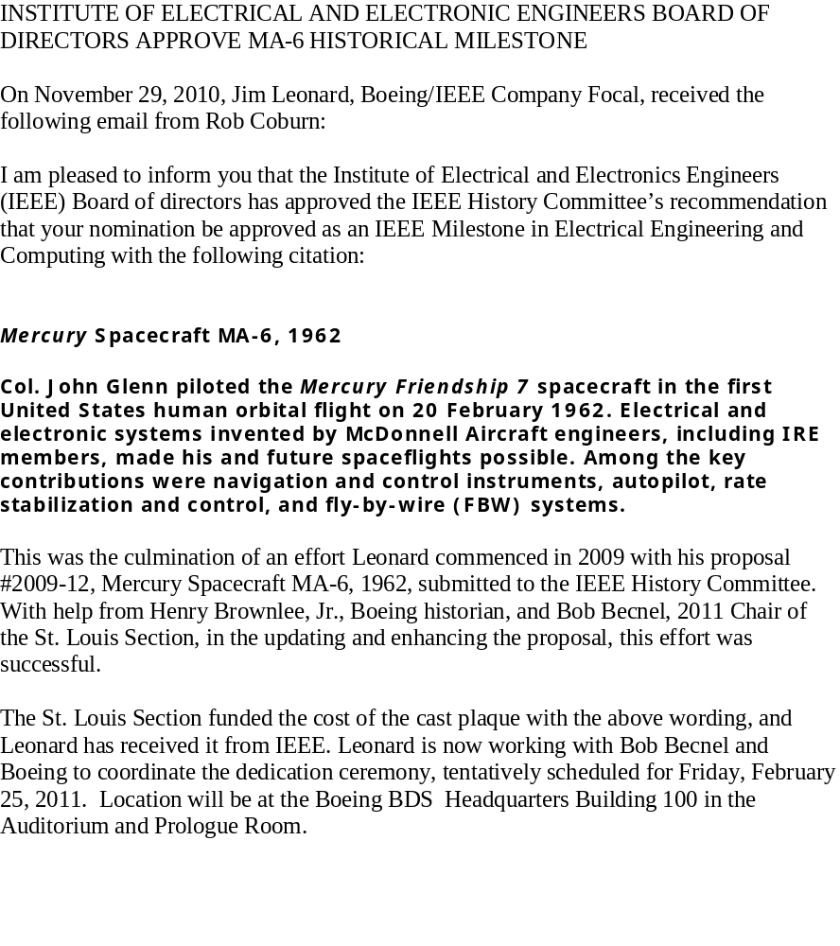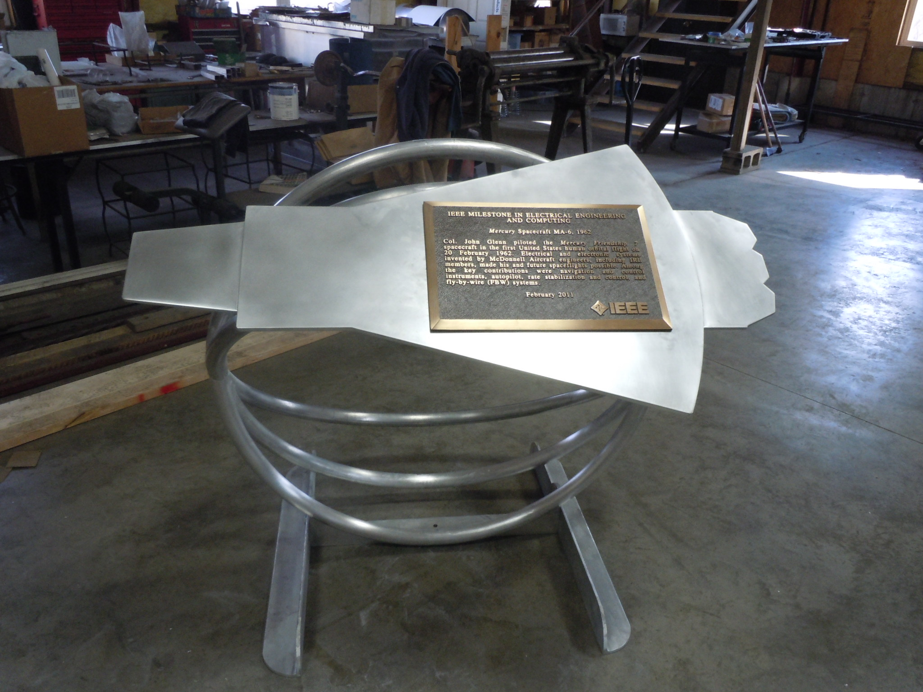
MA-6 PLAQUE MOUNTED ON A SHAPE OF THE MERCURY CAPSULE
The stand has three rings which symbolize the three orbits accomplished by Col John Glenn during his historic flight.
The dedication ceremony was held on 25 February 2011 at the Boeing St. Louis Bldg 100. A private luncheon was held with Moshe Kam (President of IEEE), Pete Sobel, Barbara Johnston, Jim Leonard, Bob Becnel, Jonathan Coopersmith (Region 5 IEEE History Chair), Debra Rub (Boeing VP), John Van Gels (Boeing VP), and Mike Burns (Boeing Customer Service). Discussions included the Boeing/IEEE Partnership Agreement and the background work done leading up to the Milestone approval. This was followed by a formal dedication ceremony. There were close to 200 attendees, including retirees from McDonnell Aircraft who worked on the Mercury spacecraft program. The program began with s short speech by John Van Gels, followed by a speech by Jim Leonard. Jim then introduced Moshe Kam, who provided the keynote speech. Dennis Muilenburg, President and CEO of Boeing Defence Systems then thanked the retirees for their Mercury accomplishments and thanked IEEE for their support of the milestone. Moshe and Dennis then officially unveiled the plaque. The event was followed by an informal social in the Boeing Prologue Room

.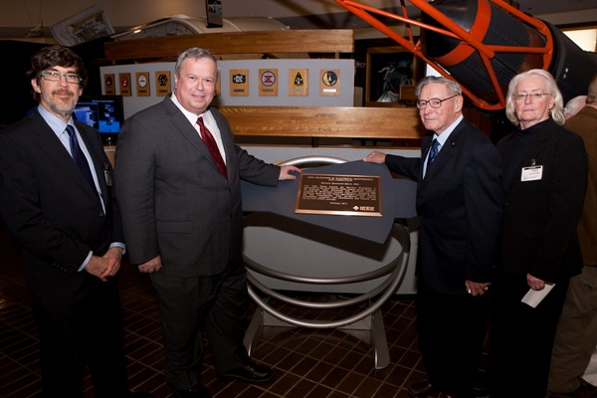
The above photo shows (Left to Right) Jon Coopersmith, Moshe Kam, Jim Leonard, and Barbara Johnston at the MA-6 Milestone plaque. The replica of the Mercury Capsule can be seen just behind Barbara.
JUDY SCHARMANN HAS CREATED SOME AESS HISTORY ITEMS:

I finished a project that I’ve wanted to do for a while, and that is to create a Presidential Gallery for all AESS Past Presidents. It can be found at: http://www.ieee-aess.org/contacts/past-presidents

Then I put our entire governance history here: http://www.ieee-aess.org/aess-governance-history

This page is not public yet because I want to make it look slightly better first. This I’ll put it up with the other rosters under About the AESS.

If anyone has any of the missing president pictures, I would be grateful if you would send to me!

I hope you like it!

Judy
The latest pub from the IEEE History Committee has some interesting articles:

5
HISTORY COMMITTEE ACTIVITIES
HISTORY COMMITTEEMEMBER PETER C. J.HILLWINS
2011 SECTIONVOLUNTEER AWARD
The IEEE United Kingdom and Republic of Ireland Section
awarded History Committee member Peter C. J. Hill its 2011
Section Volunteer Award “for his outstanding contributions to
the work of the Life Members Affinity Group, including the
organization of the GCHQ IEEE Milestone event and his leadership
in history projects.” The GCHQ Milestone was for the
invention of Public Key Cryptography.

IEEE HISTELCON TO BE HELD AT THE UNIVERSITY OF PAVIA, PAVIA, ITALY
5-8 SEPTEMBER 2012

The next IEEE International Conference on the History of Electrotechnology
will be held at the University of Pavia, in Pavia, Italy
on 5-8 September 2012. The conference, known as IEEE HISTELCON
2012 is being sponsored jointly by the IEEE Italy Section
and IEEE Region 8, and the IEEE History Center is serving as a
technical co-sponsor and as the technical program coordinator.
The theme of the 2012 conference is “The Emergence of
Electrotechnology". The University of Pavia houses the original
laboratory of Alessandro Volta and is the perfect venue for a
discussion of this theme. Topics will include: Inventors as national
heroes, early 19th century electrical science and technology,
presenting electrotechnology in museums and using
artifacts to advance historical understanding of technology, and
using the narratives related to the emergence of electrotechnology
to enhance educational curricula
The Call for Papers will be going out in the fall of 2011. In
the meanwhile, the sponsors invite Universities, Research Institutes,
Museums, and Learned Societies to technically cosponsor
this Conference, by participating in the setting up of
the program and the reviewing of provided presentations. All
advance activities will be performed by e-mail.
Queries about technical co-sponsorship or other preliminary
aspects of the Conference can be addressed to Dr. Michael
N. Geselowitz, Staff Director,

