2102 IEEE-USA PACE REPORT
The IEEE-USA Annual Meeting was held in Cincinnati, Ohio, on 3-6 May 2012. I hosted the AESS Booth which contained past copies of SYSTEMS magazine, including Tutorials issues.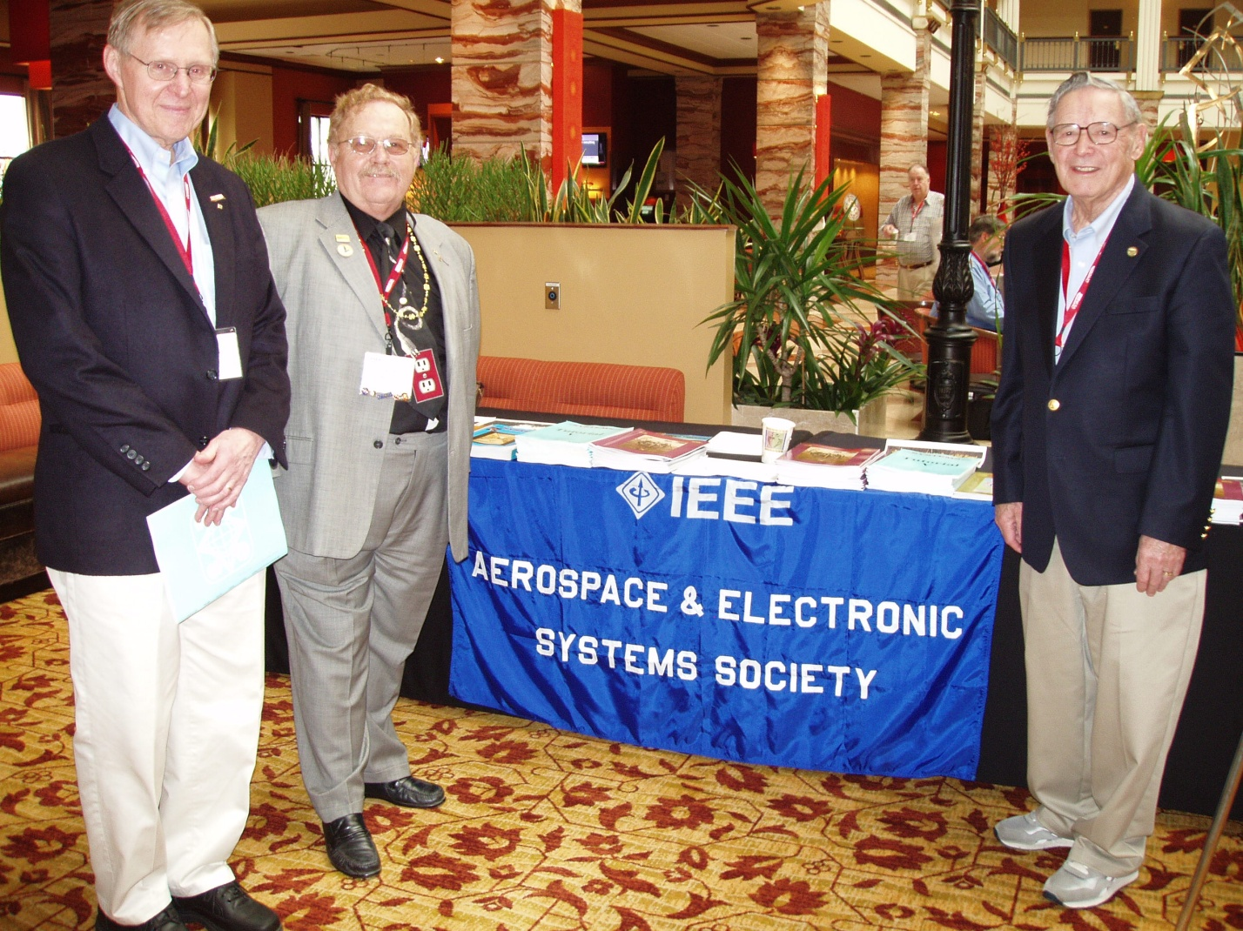
The above photo shows a typical AESS Booth setup at the IEEE-USA Annual meeting (This one held in Austin in 2011. I’m sure you recognize the characters in the photo.
In the 2012 event, we also were fortunate to have Joyce Tucker, Boeing VP for Diversity in the Workforce, present a keynote speech. This speech was videotaped and will soon be available on the IEEE-USA website.
Boeing was awarded the IEEE-USA President’s Citation for “promoting diversity in the workforce and outstanding support of US IEEE members”.
I manned the AESS Booth for the three day event. During the event many attendees came by an took copies of our AESS SYSTEMS Magazines and Tutorial issues. I pointed out that AESS does indeed provide practical articles and tutorials for the Engineer in Industry.

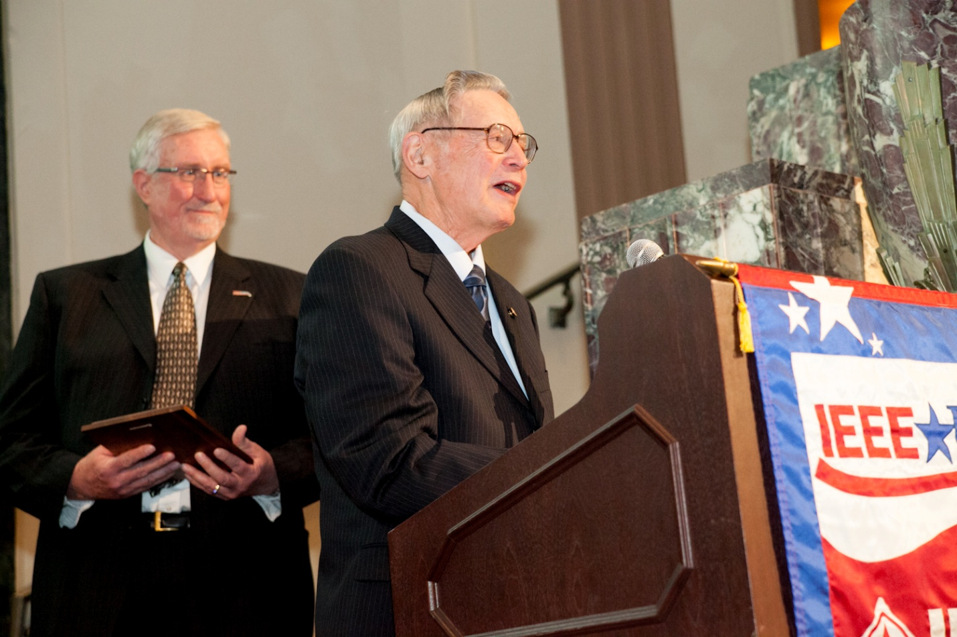
This is a photo of Jim giving the acceptance speech for the President’s Citation presented by IEEE-USA 2011 President Ron Jensen. 2012 IEEE-USA President James Howard was also present on stage.

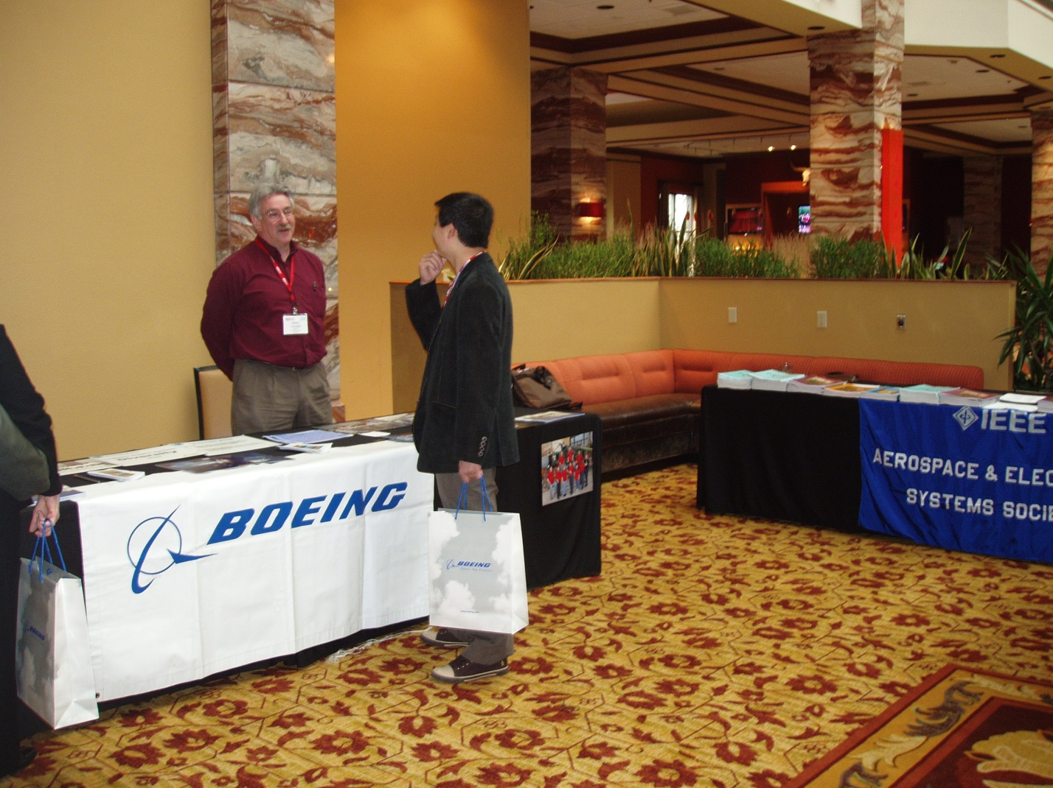
Another photo showing Mike Goodall at the Boeing Booth next to the AESS Booth.
The 2013 IEEE-USA Annual meeting will be held in Portland Oregon, in August of 2013.

